Angular
For full stack learn both ( Angular and React spring 5)
https://olympus.greatlearning.in/dashboard
First install node in your local system so you get node command terminal
https://nodejs.org/en/download/

Installing Angular CLI
Major versions of Angular CLI follow the supported major version of Angular, but minor versions can be released separately.
Install the CLI using the npm package manager:
npm install -g @angular/cli

Create a new workspace and an initial application
You develop applications in the context of an Angular workspace. A workspace contains the files for one or more projects. A project is the set of files that comprise an app, a library, or end-to-end (e2e) tests. For this tutorial, you will create a new workspace.
To create a new workspace and an initial application project:
- Ensure that you are not already in an Angular workspace folder. For example, if you have previously created the Getting Started workspace, change to the parent of that folder.
- Run the CLI command ng new and provide the name angular-tour-of-heroes, as shown here:
ng new angular-tour-of-heroes
- The ng new command prompts you for information about features to include in the initial application project. Accept the defaults by pressing the Enter or Return key.
The Angular CLI installs the necessary Angular npm packages and other dependencies. This can take a few minutes.
It also creates the following workspace and starter project files:
- A new workspace, with a root folder named angular-tour-of-heroes.
- An initial skeleton app project in the src/app subfolder.
- Related configuration files.
The initial app project contains a simple Welcome application, ready to run.

Serve the application
Go to the workspace directory and launch the application.
cd angular-tour-of-heroes
ng serve --open
The ng serve command builds the app, starts the development server, watches the source files, and rebuilds the application as you make changes to those files.
The --open flag opens a browser to http://localhost:4200/.
You should see the application running in your browser.

Angular components
The page you see is the application shell. The shell is controlled by an Angular component named AppComponent.
Components are the fundamental building blocks of Angular applications. They display data on the screen, listen for user input, and take action based on that input.

Make changes to the application
Open the project in your favorite editor or IDE and navigate to the src/app folder to make some changes to the starter application.
You'll find the implementation of the shell AppComponent distributed over three files:
- app.component.ts— the component class code, written in TypeScript.
- app.component.html— the component template, written in HTML.
- app.component.css— the component's private CSS styles.

Change the application title
Open the component class file (app.component.ts) and change the value of the title property to 'Tour of Heroes'.
app.component.ts (class title property)
title = 'Tour of Heroes';
Open the component template file (app.component.html) and delete the default template generated by the Angular CLI. Replace it with the following line of HTML.
app.component.html (template)
<h1>{{title}}</h1>
The double curly braces are Angular's interpolation binding syntax. This interpolation binding presents the component's title property value inside the HTML header tag.
The browser refreshes and displays the new application title.

Add application styles
Most apps strive for a consistent look across the application. The CLI generated an empty styles.css for this purpose. Put your application-wide styles there.
Open src/styles.css and add the code below to the file.
src/styles.css (excerpt)
content_copy/* Application-wide Styles */
h1 {
color: #369;
font-family: Arial, Helvetica, sans-serif;
font-size: 250%;
}
h2, h3 {
color: #444;
font-family: Arial, Helvetica, sans-serif;
font-weight: lighter;
}
body {
margin: 2em;
}
body, input[type="text"], button {
color: #333;
font-family: Cambria, Georgia, serif;
}
/* everywhere else */
* {
font-family: Arial, Helvetica, sans-serif;
}
Step-2: Create new project by this command
ng new myNewApp
Step-3: Go to your project directory
cd myNewApp
Step-4: Run server and see your application in action

Run Angular Application
To run an Angular application in the browser, you first need to build it.
You can build and run applications either using Angular CLI command or NPM command. You can use the terminal/command window to execute these commands. However, if you are using VS Code then you can execute commands from its terminal.
Use Angular CLI command ng serve -o to build an application. The -o indicates to open it automatically in the default browser.
Use NPM command npm start to build an application. Internally, it uses ng serve command only. Open a browser and navigate to http://localhost:4200 to see the application home page. The http://localhost:4200 is the default URL of an Angular application created using Angular CLI.
Open the terminal in VS Code from menu Terminal -> New Terminal, and type ng serve -o command and press enter, as shown below.

ng serve -o --poll=2000
The ng serve command builds the app, starts the development server, watches the source files, and rebuilds the app as you make changes to those files. It will open your Angular application in the default browser, as shown below.
you will get belo project :- 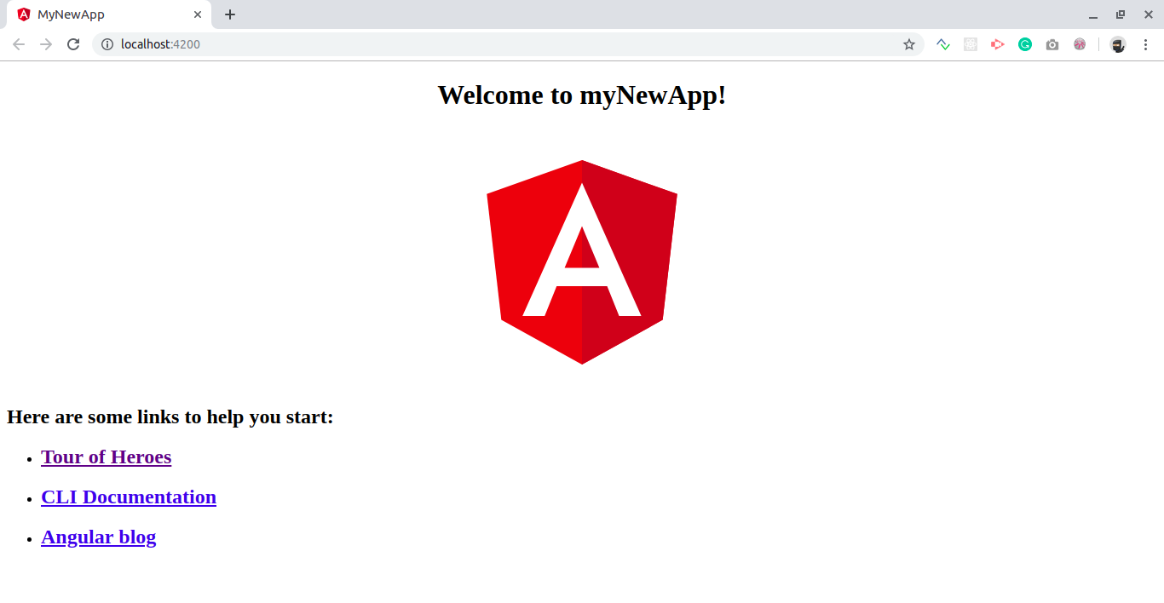
The ng serve command keep watching source files, so if you make any changes in any file of the project, it will rebuild it and refresh the browser automatically to reflect the changes.
To stop the automatic build process, press Ctrl + c in the terminal of VS Code.
Thus, you can create a workspace and an initial Angular project and run it using VS Code.

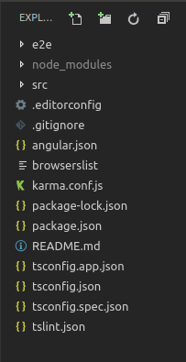
- e2e It contains the code related to automated testing purpose. For example, if on a certain page you are calling a REST API then what should be the return status code, whether it is acceptable or not etc.
- node_modules It saves all the dev dependencies (used only at development time) and dependencies (used for development as well as needed in production time), any new dependency when added to project it is automatically saved to this folder.
- src This directory contains all of our work related to project i.e. creating components, creating services, adding CSS to the respective page, etc.
- package.json This file stores the information about the libraries added and used in the project with their specified version installed. Whenever a new library is added to the project it’s name and version is added to the dependencies in package.json.
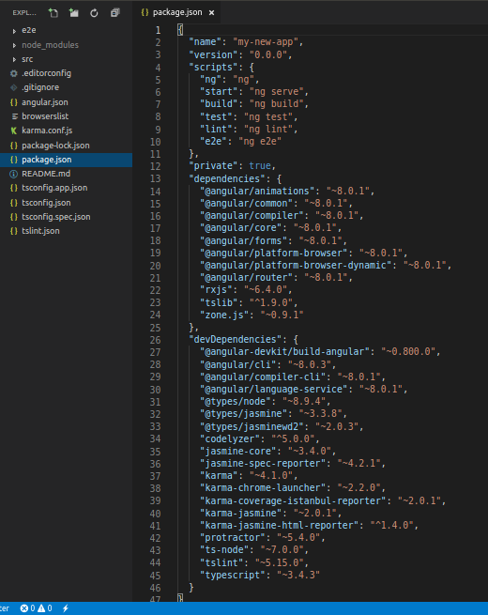
Other files: As a beginner you don’t need these files at this time, don’t bother about that. These all are used for editor configurations and information needed at compile time. The builtin webpack in angular CLI manages all for you.
Inside src folder:
- index.html This is the entry point for the application, app-root tag is the entry point of the application on this single page application, on this page angular will add or remove the content from the DOM or will add new content to the DOM. Base href=”/” is important for routing purposes.
<!DOCTYPE HTML>
<html lang="en">
<head>
<meta charset="utf-8">
<title>MyNewApp</title>
<base href="/">

<meta name="viewport" content="width=device-width, initial-scale=1">
<link rel="icon" typw="image/x-icon" href="favison.ico">
</head>
<body>
<app-root></app-root>
</body>
</html>
- style.scss This file is the global stylesheet you can add that CSS classes or selectors which are common to many components, for example, you can import custom fonts, import bootstrap.css, etc.
- assets It contains the js images, fonts, icons and many other files for your project.
Inside app folder:
- app.module.ts An angular project is composite of so many other modules in order to create an application you have to create a root module for your application in the hierarchy. This app.module.ts file is that. If you want to add more modules at the root level, you can add.
  - declarations It is the reference of the array to store its components. The app component is the default component that is generated when a project is created. You have to add all your component’s reference to this array to make them available in the project.
  - imports If you want to add any module whether angular or you have to add it to imports array to make them available in the whole project.
  - providers If you will create any service for your application then you will inject it into your project through this provider array. Service injected to a module is available to it and it’s child module in the project hierarchy.
  - bootstrap This has reference to the default component created, i.e., AppComponent
- app.component.html Edit this file to make changes to the page. You can edit this file as an HTML file. Work directly with div or any other tag used inside body tags, these are components and do not add html head body tags.
<h1>
Hello world
</h1>

<div>
<p>
This is my First Angular app.
</p>
</div>
- app.component.spec.ts These are automatically generated files which contain unit tests for source component.
- app.component.ts You can do the processing of the HTML structure in the .ts file. The processing will include activities such as connecting to the database, interacting with other components, routing, services, etc.
- app.component.scss Here you can add CSS for your component. You can write scss which further compiled to CSS by a transpiler.
More commands that you will need while working on the project:
ng generate component component_name
ng generate service service_name
ng generate directive directive_name

Major part of the development with Angular 6 is done in the components. Components are basically classes that interact with the .html file of the component, which gets displayed on the browser. We have seen the file structure in one of our previous chapters. The file structure has the app component and it consists of the following files –
Angular Components :-
- app.component.css
- app.component.html
- app.component.spec.ts
- app.component.ts
- app.module.ts
The above files were created by default when we created new project using the angular-cli command.
If you open up the app.module.ts file, it has some libraries which are imported and also a declarative which is assigned the appcomponent as follows −
import { BrowserModule } from '@angular/platform-browser';
import { NgModule } from '@angular/core';
import { AppComponent } from './app.component';
@NgModule({
declarations: [
AppComponent
],
imports: [
BrowserModule
],
providers: [],
bootstrap: [AppComponent]
})
export class AppModule { }
The declarations include the AppComponent variable, which we have already imported. This becomes the parent component.
Now, angular-cli has a command to create your own component. However, the app component which is created by default will always remain the parent and the next components created will form the child components.
Let us now run the command to create the component.
ng generate component new-cmp
When you run the above command in the command line, you will receive the following output −
D:\Node\Angular6App>ng generate component new-cmp
CREATE src/app/new-cmp/new-cmp.component.html (26 bytes)
CREATE src/app/new-cmp/new-cmp.component.spec.ts (629 bytes)
CREATE src/app/new-cmp/new-cmp.component.ts (272 bytes)
CREATE src/app/new-cmp/new-cmp.component.css (0 bytes)
UPDATE src/app/app.module.ts (398 bytes)
Now, if we go and check the file structure, we will get the new-cmp new folder created under the src/app folder.
The following files are created in the new-cmp folder −
- new-cmp.component.css − css file for the new component is created.
- new-cmp.component.html − html file is created.
- new-cmp.component.spec.ts − this can be used for unit testing.
- new-cmp.component.ts − here, we can define the module, properties, etc.
Changes are added to the app.module.ts file as follows −
import { BrowserModule } from '@angular/platform-browser';
import { NgModule } from '@angular/core';
import { AppComponent } from './app.component';
import { NewCmpComponent } from './new-cmp/new-cmp.component';
// includes the new-cmp component we created
@NgModule({
declarations: [
AppComponent,
NewCmpComponent // here it is added in declarations and will behave as a child component
],
imports: [
BrowserModule
],
providers: [],
bootstrap: [AppComponent] //for bootstrap the AppComponent the main app component is given.
})

export class AppModule { }
The new-cmp.component.ts file is generated as follows −
import { Component, OnInit } from '@angular/core'; // here angular/core is imported .
@Component({
// this is a declarator which starts with @ sign. The component word marked in bold needs to be the same.
selector: 'app-new-cmp', //
templateUrl: './new-cmp.component.html',
// reference to the html file created in the new component.
styleUrls: ['./new-cmp.component.css'] // reference to the style file.
})
export class NewCmpComponent implements OnInit {
constructor() { }
ngOnInit() {}
}
If you see the above new-cmp.component.ts file, it creates a new class called NewCmpComponent, which implements OnInit.In, which has a constructor and a method called ngOnInit(). ngOnInit is called by default when the class is executed.
Let us check how the flow works. Now, the app component, which is created by default becomes the parent component. Any component added later becomes the child component.
When we hit the url in the http://localhost:4200/ browser, it first executes the index.html file which is shown below −
<!doctype html>
<html lang = "en">
<head>
<meta charset = "utf-8">
<title>Angular 6 Application</title>
<base href = "/">
<meta name = "viewport" content = "width = device-width, initial-scale = 1">
<link rel = "icon" type = "image/x-icon" href = "favicon.ico">
</head>
<body>
<app-root></app-root>
</body>
</html>
The above is the normal html file and we do not see anything that is printed in the browser. Take a look at the tag in the body section.
<app-root></app-root>
This is the root tag created by the Angular by default. This tag has the reference in the main.ts file.
import { enableProdMode } from '@angular/core';
import { platformBrowserDynamic } from '@angular/platform-browser-dynamic';
import { AppModule } from './app/app.module';
import { environment } from './environments/environment';
if (environment.production) {
enableProdMode();
}
platformBrowserDynamic().bootstrapModule(AppModule);
AppModule is imported from the app of the main parent module, and the same is given to the bootstrap Module, which makes the appmodule load.
Let us now see the app.module.ts file −
import { BrowserModule } from '@angular/platform-browser';
import { NgModule } from '@angular/core';
import { AppComponent } from './app.component';
import { NewCmpComponent } from './new-cmp/new-cmp.component';
@NgModule({
declarations: [
AppComponent,
NewCmpComponent
],
imports: [
BrowserModule
],
providers: [],
bootstrap: [AppComponent]
})

export class AppModule { }
Here, the AppComponent is the name given, i.e., the variable to store the reference of the app. Component.ts and the same is given to the bootstrap. Let us now see the app.component.ts file.
import { Component } from '@angular/core';
@Component({
selector: 'app-root',
templateUrl: './app.component.html',
styleUrls: ['./app.component.css']
})
export class AppComponent {
title = 'Angular 6 Project!';
}
Angular core is imported and referred as the Component and the same is used in the Declarator as −
@Component({
selector: 'app-root',
templateUrl: './app.component.html',
styleUrls: ['./app.component.css']
})
In the declarator reference to the selector, templateUrl and styleUrl are given. The selector here is nothing but the tag which is placed in the index.html file that we saw above.
The class AppComponent has a variable called title, which is displayed in the browser.
The @Component uses the templateUrl called app.component.html which is as follows −
<!--The content below is only a placeholder and can be replaced.-->
<div style = "text-align:center">
<h1>
Welcome to {{title}}.
</h1>
</div>
It has just the html code and the variable title in curly brackets. It gets replaced with the value, which is present in the app.component.ts file. This is called binding. We will discuss the concept of binding in a subsequent chapter.
Now that we have created a new component called new-cmp. The same gets included in the app.module.ts file, when the command is run for creating a new component.
app.module.ts has a reference to the new component created.
Let us now check the new files created in new-cmp.

new-cmp.component.ts
import { Component, OnInit } from '@angular/core';
@Component({
selector: 'app-new-cmp',
templateUrl: './new-cmp.component.html',
styleUrls: ['./new-cmp.component.css']
})
export class NewCmpComponent implements OnInit {
constructor() { }
ngOnInit() {}
}
Here, we have to import the core too. The reference of the component is used in the declarator.
The declarator has the selector called app-new-cmp and the templateUrl and styleUrl.
The .html called new-cmp.component.html is as follows −
<p>
new-cmp works!
</p>
As seen above, we have the html code, i.e., the p tag. The style file is empty as we do not need any styling at present. But when we run the project, we do not see anything related to the new component getting displayed in the browser. Let us now add something and the same can be seen in the browser later.
The selector, i.e., app-new-cmp needs to be added in the app.component .html file as follows −
<!--The content below is only a placeholder and can be replaced.-->
<div style = "text-align:center">
<h1>
Welcome to {{title}}.
</h1>
</div>
<app-new-cmp></app-new-cmp>
When the <app-new-cmp></app-new-cmp> tag is added, all that is present in the .html file of the new component created will get displayed on the browser along with the parent component data.
Let us see the new component .html file and the new-cmp.component.ts file.

new-cmp.component.ts
import { Component, OnInit } from '@angular/core';
@Component({
selector: 'app-new-cmp',
templateUrl: './new-cmp.component.html',
styleUrls: ['./new-cmp.component.css']
})
export class NewCmpComponent implements OnInit {
newcomponent = "Entered in new component created";
constructor() {}
ngOnInit() { }
}
In the class, we have added one variable called new component and the value is "Entered in new component created".
The above variable is bound in the .new-cmp.component.html file as follows −
<p>
{{newcomponent}}
</p>
<p>
new-cmp works!
</p>
Now since we have included the <app-new-cmp></app-new-cmp> selector in the app. component .html which is the .html of the parent component, the content present in the new component .html file (new-cmp.component.html) gets displayed on the browser as follows −
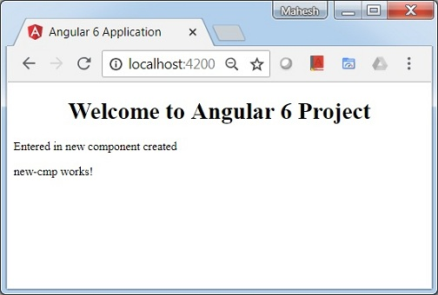
Similarly, we can create components and link the same using the selector in the app.component.html file as per our requirements.
Module in Angular refers to a place where you can group the components, directives, pipes, and services, which are related to the application.
In case you are developing a website, the header, footer, left, center and the right section become part of a module.
To define module, we can use the NgModule. When you create a new project using the Angular -cli command, the ngmodule is created in the app.module.ts file by default and it looks as follows −
import { BrowserModule } from '@angular/platform-browser';
import { NgModule } from '@angular/core';
import { AppComponent } from './app.component';
@NgModule({
declarations: [
AppComponent
],
imports: [
BrowserModule
],
providers: [],
bootstrap: [AppComponent]
})
export class AppModule { }
The NgModule needs to be imported as follows −
import { NgModule } from '@angular/core';
The structure for the ngmodule is as shown below −
@NgModule({
declarations: [
AppComponent
],
imports: [
BrowserModule
],
providers: [],
bootstrap: [AppComponent]
})
It starts with @NgModule and contains an object which has declarations, import s, providers and bootstrap.

Declaration
It is an array of components created. If any new component gets created, it will be imported first and the reference will be included in declarations as shown below −
declarations: [
AppComponent,
NewCmpComponent
]

Import
It is an array of modules required to be used in the application. It can also be used by the components in the Declaration array. For example, right now in the @NgModule we see the Browser Module imported. In case your application needs forms, you can include the module as follows −
import { FormsModule } from '@angular/forms';
The import in the @NgModule will be like the following −
imports: [
BrowserModule,
FormsModule
]

Providers
This will include the services created.

Bootstrap
This includes the main app component for starting the execution.
Angular Binding :-
Data Binding is available right from AngularJS, Angular 2,4 and is now available in Angular 6 as well. We use curly braces for data binding - {{}}; this process is called interpolation. We have already seen in our previous examples how we declared the value to the variable title and the same is printed in the browser.
The variable in the app.component.html file is referred as {{title}} and the value of title is initialized in the app.component.ts file and in app.component.html, the value is displayed.
Let us now create a dropdown of months in the browser. To do that , we have created an array of months in app.component.ts as follows −
import { Component } from '@angular/core';
@Component({
selector: 'app-root',
templateUrl: './app.component.html',
styleUrls: ['./app.component.css']
})
export class AppComponent {
title = 'Angular 6 Project!';
// declared array of months.
months = ["January", "Feburary", "March", "April", "May",
"June", "July", "August", "September",
"October", "November", "December"];
}
The month's array that is shown above is to be displayed in a dropdown in the browser. For this, we will use the following line of code −
<!--The content below is only a placeholder and can be replaced. -->
<div style = "text-align:center">
<h1>
Welcome to {{title}}.
</h1>
</div>
<div> Months :
<select>
<option *ngFor = "let i of months">{{i}}</option>
</select>
</div>
We have created the normal select tag with option. In option, we have used the for loop. The for loop is used to iterate over the months' array, which in turn will create the option tag with the value present in the months.
The syntax for in Angular is *ngFor = "let I of months" and to get the value of months we are displaying it in {{i}}.
The two curly brackets help with data binding. You declare the variables in your app.component.ts file and the same will be replaced using the curly brackets.
Let us see the output of the above month's array in the browser

The variable that is set in the app.component.ts can be bound with the app.component.html using the curly brackets; for example, {{}}.
Let us now display the data in the browser based on condition. Here, we have added a variable and assigned the value as true. Using the if statement, we can hide/show the content to be displayed.
Example
import { Component } from '@angular/core';
@Component({
selector: 'app-root',
templateUrl: './app.component.html',
styleUrls: ['./app.component.css']
})
export class AppComponent {
title = 'Angular 4 Project!';
//array of months.
months = ["January", "February", "March", "April",
"May", "June", "July", "August", "September",
"October", "November", "December"];
isavailable = true; //variable is set to true
}
<!--The content below is only a placeholder and can be replaced.-->
<div style = "text-align:center">
<h1>
Welcome to {{title}}.
</h1>
</div>
<div> Months :
<select>
<option *ngFor = "let i of months">{{i}}</option>
</select>
</div>
<br/>
<div>
<span *ngIf = "isavailable">Condition is valid.</span>
<!--over here based on if condition the text condition is valid is displayed.
If the value of isavailable is set to false it will not display the text.-->
</div>
Output

Let us try the above example using the IF THEN ELSE condition.
Example
import { Component } from '@angular/core';
@Component({
selector: 'app-root',
templateUrl: './app.component.html',
styleUrls: ['./app.component.css']
})
export class AppComponent {
title = 'Angular 4 Project!';
//array of months.
months = ["January", "February", "March", "April",
"May", "June", "July", "August", "September",
"October", "November", "December"];
isavailable = false;
}
In this case, we have made the isavailable variable as false. To print the else condition, we will have to create the ng-template as follows −
<ng-template #condition1>Condition is invalid</ng-template>
The full code looks like this −
<!--The content below is only a placeholder and can be replaced.-->
<div style = "text-align:center">
<h1>
Welcome to {{title}}.
</h1>
</div>
<div> Months :
<select>
<option *ngFor="let i of months">{{i}}</option>
</select>
</div>
<br/>
<div>
<span *ngIf = "isavailable; else condition1">Condition is valid.</span>
<ng-template #condition1>Condition is invalid</ng-template>
</div>
If is used with the else condition and the variable used is condition1. The same is assigned as an id to the ng-template, and when the available variable is set to false the text Condition is invalid is displayed.
The following screenshot shows the display in the browser.

Let us now use the if then else condition.
import { Component } from '@angular/core';
@Component({
selector: 'app-root',
templateUrl: './app.component.html',
styleUrls: ['./app.component.css']
})
export class AppComponent {
title = 'Angular 4 Project!';
//array of months.
months = ["January", "February", "March", "April",
"May", "June", "July", "August", "September",
"October", "November", "December"];
isavailable = true;
}
Now, we will make the variable isavailable as true. In the html, the condition is written in the following way −
<!--The content below is only a placeholder and can be replaced.-->
<div style = "text-align:center">
<h1>
Welcome to {{title}}.
</h1>
</div>
<div> Months :
<select>
<option *ngFor = "let i of months">{{i}}</option>
</select>
</div>
<br/>
<div>
<span *ngIf = "isavailable; then condition1 else condition2">Condition is valid.</span>
<ng-template #condition1>Condition is valid</ng-template>
<ng-template #condition2>Condition is invalid</ng-template>
</div>
If the variable is true, then condition1, else condition2. Now, two templates are created with id #condition1 and #condition2.

Angular 6 - Templates
Angular 6 uses the <ng-template> as the tag similar to Angular 4 instead of <template> which is used in Angular2. The reason Angular 4 changed <template> to <ng-template> is because there is a name conflict between the <template> tag and the html <template> standard tag. It will deprecate completely going ahead.
Let us now use the template along with the if else condition and see the output.

app.component.html
<!--The content below is only a placeholder and can be replaced.-->
<div style = "text-align:center">
<h1>
Welcome to {{title}}.
</h1>
</div>
<div> Months :
<select (change) = "changemonths($event)" name = "month">
<option *ngFor = "let i of months">{{i}}</option>
</select>
</div>
<br/>
<div>
<span *ngIf = "isavailable;then condition1 else condition2">Condition is valid.</span>
<ng-template #condition1>Condition is valid from template</ng-template>
<ng-template #condition2>Condition is invalid from template</ng-template>
</div>
<button (click) = "myClickFunction($event)">Click Me</button>
For the Span tag, we have added the if statement with the else condition and will call template condition1, else condition2.
The templates are to be called as follows −
<ng-template #condition1>Condition is valid from template</ng-template>
<ng-template #condition2>Condition is invalid from template</ng-template>
If the condition is true, then the condition1 template is called, otherwise condition2.

app.component.ts
import { Component } from '@angular/core';
@Component({
selector: 'app-root',
templateUrl: './app.component.html',
styleUrls: ['./app.component.css']
})
export class AppComponent {
title = 'Angular 6 Project!';
//array of months.
months = ["January", "February", "March", "April",
"May", "June", "July", "August", "September",
"October", "November", "December"];
isavailable = false;
myClickFunction(event) {
this.isavailable = false;
}
changemonths(event) {
alert("Changed month from the Dropdown");
console.log(event);
}
}
The output in the browser is as follows −
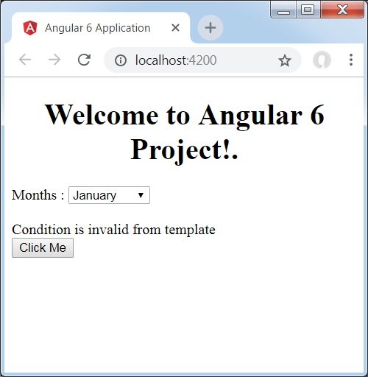
The variable isavailable is false so the condition2 template is printed. If you click the button, the respective template will be called. If you inspect the browser, you will see that you never get the span tag in the dom. The following example will help you understand the same.
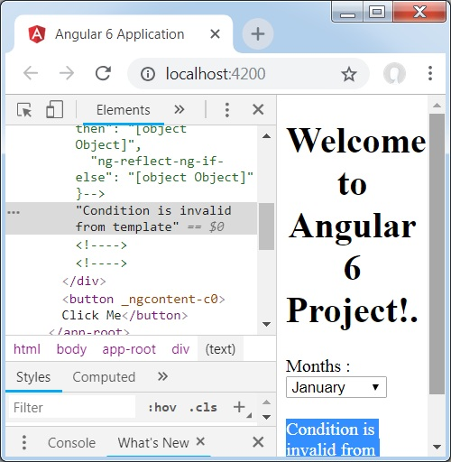
If you inspect the browser, you will see that the dom does not have the span tag. It has the Condition is invalid from template in the dom.
The following line of code in html will help us get the span tag in the dom.
<!--The content below is only a placeholder and can be replaced.-->
<div style = "text-align:center">
<h1>
Welcome to {{title}}.
</h1>
</div>
<div> Months :
<select (change) = "changemonths($event)" name = "month">
<option *ngFor = "let i of months">{{i}}</option>
</select>
</div>
<br/>
<div>
<span *ngIf = "isavailable; else condition2">Condition is valid.</span>
<ng-template #condition1>Condition is valid from template</ng-template>
<ng-template #condition2>Condition is invalid from template</ng-template>
</div>
<button (click)="myClickFunction($event)">Click Me</button>
If we remove the then condition, we get the "Condition is valid" message in the browser and the span tag is also available in the dom. For example, in app.component.ts, we have made the isavailable variable as true.
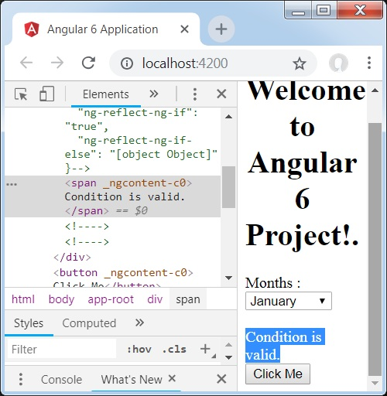

Angular 6 - Directives
Directives in Angular is a js class, which is declared as @directive. We have 3 directives in Angular. The directives are listed below −

Component Directives
These form the main class having details of how the component should be processed, instantiated and used at runtime.
As we saw earlier, components are just directives with templates. Under the hood, they use the directive API and give us a cleaner way to define them.
The other two directive types don’t have templates. Instead, they’re specifically tailored to DOM manipulation.

Structural Directives
A structure directive basically deals with manipulating the dom elements. Structural directives have a * sign before the directive. For example, *ngIf and *ngFor.

Attribute Directives
Attribute directives manipulate the DOM by changing its behavior and appearance.
We use attribute directives to apply conditional style to elements, show or hide elements or dynamically change the behavior of a component according to a changing property.

How to Create Custom Directives?
In this section, we will discuss about Custom Directives to be used in components. Custom directives are created by us and are not standard.
Let us see how to create the custom directive. We will create the directive using the command line. The command to create the directive using the command line is −
ng g directive nameofthedirective
e.g
ng g directive changeText
This is how it appears in the command line
C:\projectA6\Angular6App>ng g directive changeText
CREATE src/app/change-text.directive.spec.ts (241 bytes)
CREATE src/app/change-text.directive.ts (149 bytes)
UPDATE src/app/app.module.ts (486 bytes)
The above files, i.e., change-text.directive.spec.ts and change-text.directive.ts get created and the app.module.ts file is updated.

app.module.ts
import { BrowserModule } from '@angular/platform-browser';
import { NgModule } from '@angular/core';
import { AppComponent } from './app.component';
import { NewCmpComponent } from './new-cmp/new-cmp.component';
import { ChangeTextDirective } from './change-text.directive';
@NgModule({
declarations: [
AppComponent,
NewCmpComponent,
ChangeTextDirective
],
imports: [
BrowserModule
],
providers: [],
bootstrap: [AppComponent]
})
export class AppModule { }
The ChangeTextDirective class is included in the declarations in the above file. The class is also imported from the file given below.

change-text. directive
import { Directive } from '@angular/core';
@Directive({
selector: '[appChangeText]'
})
export class ChangeTextDirective {
constructor() { }
}
The above file has a directive and it also has a selector property. Whatever we define in the selector, the same has to match in the view, where we assign the custom directive.
In the app.component.html view, let us add the directive as follows −
<div style = "text-align:center">
<span appChangeText >Welcome to {{title}}.</span>
</div>
We will write the changes in change-text.directive.ts file as follows −

change-text.directive.ts
import { Directive, ElementRef} from '@angular/core';
@Directive({
selector: '[appChangeText]'
})
export class ChangeTextDirective {
constructor(Element: ElementRef) {
console.log(Element);
Element.nativeElement.innerText = "Text is changed by changeText Directive. ";
}
}
In the above file, there is a class called ChangeTextDirective and a constructor, which takes the element of type ElementRef, which is mandatory. The element has all the details to which the Change Text directive is applied.
We have added the console.log element. The output of the same can be seen in the browser console. The text of the element is also changed as shown above.
Now, the browser will show the following.
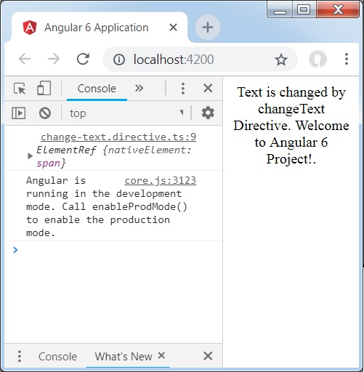

Angular 6 - Pipes
In this chapter, we will discuss what are Pipes in Angular 6. Pipes were earlier called filters in Angular1 and called pipes in Angular 2 onwards.
The | character is used to transform data. Following is the syntax for the same
{{ Welcome to Angular 6 | lowercase}}
It takes integers, strings, arrays, and date as input separated with | to be converted in the format as required and display the same in the browser.
Let us consider a few examples using pipes.
Here, we want to display the text given to uppercase. This can be done using pipes as follows −
In the app.component.ts file, we have defined the title variable −

app.component.ts
import { Component } from '@angular/core';
@Component({
selector: 'app-root',
templateUrl: './app.component.html',
styleUrls: ['./app.component.css']
})
export class AppComponent {
title = 'Angular 6 Project!';
}
The following line of code goes into the app.component.html file.
<b>{{title | uppercase}}</b><br/>
<b>{{title | lowercase}}</b>
The browser appears as shown in the following screenshot −
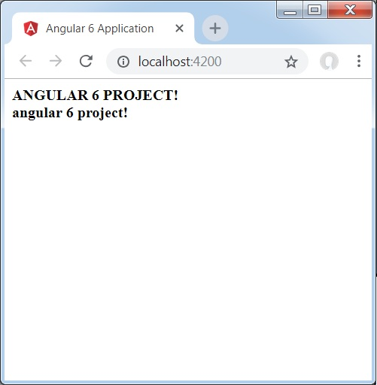
Angular 6 provides some built-in pipes. The pipes are listed below −
- Lowercasepipe
- Uppercasepipe
- Datepipe
- Currencypipe
- Jsonpipe
- Percentpipe
- Decimalpipe
- Slicepipe
We have already seen the lowercase and uppercase pipes. Let us now see how the other pipes work.
The following line of code will help us define the required variables in app.component.ts file −
import { Component } from '@angular/core';
@Component({
selector: 'app-root',
templateUrl: './app.component.html',
styleUrls: ['./app.component.css']
})
export class AppComponent {
title = 'Angular 6 Project!';
todaydate = new Date();
jsonval = {name:'Rox', age:'25', address:{a1:'Mumbai', a2:'Karnataka'}};
months = ["Jan", "Feb", "Mar", "April", "May", "Jun",
"July", "Aug", "Sept", "Oct", "Nov", "Dec"];
}
We will use the pipes in the app.component.html file.
<!--The content below is only a placeholder and can be replaced.-->
<div style = "width:100%;">
<div style = "width:40%;float:left;border:solid 1px black;">
<h1>Uppercase Pipe</h1>
<b>{{title | uppercase}}</b><br/>
<h1>Lowercase Pipe</h1>
<b>{{title | lowercase}}</b>
<h1>Currency Pipe</h1>
<b>{{6589.23 | currency:"USD"}}</b><br/>
<b>{{6589.23 | currency:"USD":true}}</b> //Boolean true is used to get the sign of the currency.
<h1>Date pipe</h1>
<b>{{todaydate | date:'d/M/y'}}</b><br/>
<b>{{todaydate | date:'shortTime'}}</b>
<h1>Decimal Pipe</h1>
<b>{{ 454.78787814 | number: '3.4-4' }}</b> // 3 is for main integer, 4 -4 are for integers to be displayed.
</div>
<div style = "width:40%;float:left;border:solid 1px black;">
<h1>Json Pipe</h1>
<b>{{ jsonval | json }}</b>
<h1>Percent Pipe</h1>
<b>{{00.54565 | percent}}</b>
<h1>Slice Pipe</h1>
<b>{{months | slice:2:6}}</b>
// here 2 and 6 refers to the start and the end index
</div>
</div>
The following screenshots show the output for each pipe −
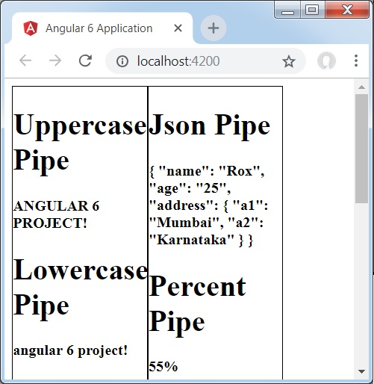
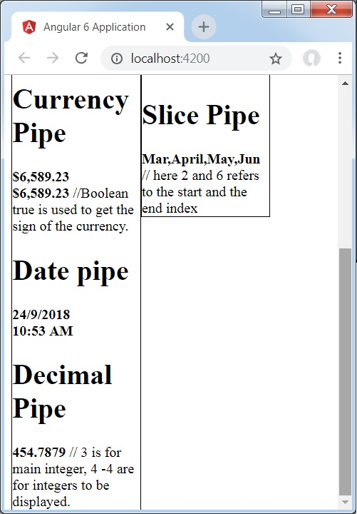

How to Create a Custom Pipe?
To create a custom pipe, we have created a new ts file. Here, we want to create the sqrt custom pipe. We have given the same name to the file and it looks as follows −

app.sqrt.ts
import {Pipe, PipeTransform} from '@angular/core';
@Pipe ({
name : 'sqrt'
})
export class SqrtPipe implements PipeTransform {
transform(val : number) : number {
return Math.sqrt(val);
}
}
To create a custom pipe, we have to import Pipe and Pipe Transform from Angular/core. In the @Pipe directive, we have to give the name to our pipe, which will be used in our .html file. Since, we are creating the sqrt pipe, we will name it sqrt.
As we proceed further, we have to create the class and the class name is SqrtPipe. This class will implement the PipeTransform.
The transform method defined in the class will take argument as the number and will return the number after taking the square root.
Since we have created a new file, we need to add the same in app.module.ts. This is done as follows −
import { BrowserModule } from '@angular/platform-browser';
import { NgModule } from '@angular/core';
import { AppComponent } from './app.component';
import { NewCmpComponent } from './new-cmp/new-cmp.component';
import { ChangeTextDirective } from './change-text.directive';
import { SqrtPipe } from './app.sqrt';
@NgModule({
declarations: [
SqrtPipe,
AppComponent,
NewCmpComponent,
ChangeTextDirective
],
imports: [
BrowserModule
],
providers: [],
bootstrap: [AppComponent]
})
export class AppModule { }
We have created the app.sqrt.ts class. We have to import the same in app.module.ts and specify the path of the file. It also has to be included in the declarations as shown above.
Let us now see the call made to the sqrt pipe in the app.component.html file.
<h1>Custom Pipe</h1>
<b>Square root of 25 is: {{25 | sqrt}}</b>
<br/>
<b>Square root of 729 is: {{729 | sqrt}}</b>
The output looks as follows −
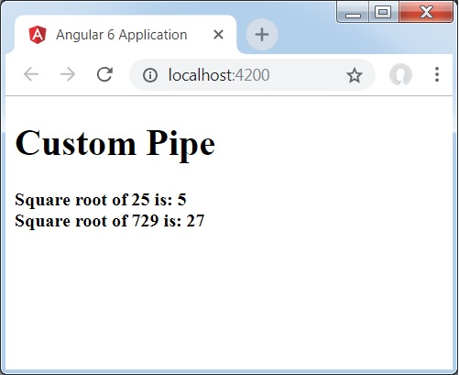

Angular 6 - Routing
Routing basically means navigating between pages. You have seen many sites with links that direct you to a new page. This can be achieved using routing. Here the pages that we are referring to will be in the form of components. We have already seen how to create a component. Let us now create a component and see how to use routing with it.
In the main parent component app.module.ts, we have to now include the router module as shown below −
import { BrowserModule } from '@angular/platform-browser';
import { NgModule } from '@angular/core';
import { RouterModule} from '@angular/router';
import { AppComponent } from './app.component';
import { NewCmpComponent } from './new-cmp/new-cmp.component';
import { ChangeTextDirective } from './change-text.directive';
import { SqrtPipe } from './app.sqrt';
@NgModule({
declarations: [
SqrtPipe,
AppComponent,
NewCmpComponent,
ChangeTextDirective
],
imports: [
BrowserModule,
RouterModule.forRoot([
{
path: 'new-cmp',
component: NewCmpComponent
}
])
],
providers: [],
bootstrap: [AppComponent]
})
export class AppModule { }
import { RouterModule} from '@angular/router'
Here, the RouterModule is imported from angular/router. The module is included in the imports as shown below −
RouterModule.forRoot([
{
path: 'new-cmp',
component: NewCmpComponent
}
])
RouterModule refers to the forRoot which takes an input as an array, which in turn has the object of the path and the component. Path is the name of the router and component is the name of the class, i.e., the component created.
Let us now see the component created file −
New-cmp.component.ts
import { Component, OnInit } from '@angular/core';
@Component({
selector: 'app-new-cmp',
templateUrl: './new-cmp.component.html',
styleUrls: ['./new-cmp.component.css']
})
export class NewCmpComponent implements OnInit {
newcomponent = "Entered in new component created";
constructor() {}
ngOnInit() { }
}
The highlighted class is mentioned in the imports of the main module.
New-cmp.component.html
<p>
{{newcomponent}}
</p>

<p>
new-cmp works!
</p>
Now, we need the above content from the html file to be displayed whenever required or clicked from the main module. For this, we need to add the router details in the app.component.html.
<h1>Custom Pipe</h1>
<b>Square root of 25 is: {{25 | sqrt}}</b><br/>
<b>Square root of 729 is: {{729 | sqrt}}</b>
<br />
<br />
<br />
<a routerLink = "new-cmp">New component</a>
<br />
<br/>
<router-outlet></router-outlet>
In the above code, we have created the anchor link tag and given routerLink as "new-cmp". This is referred in app.module.ts as the path.
When a user clicks new component, the page should display the content. For this, we need the following tag - <router-outlet> </router-outlet>.
The above tag ensures that the content in the new-cmp.component.html will be displayed on the page when a user clicks new component.
Let us now see how the output is displayed on the browser.
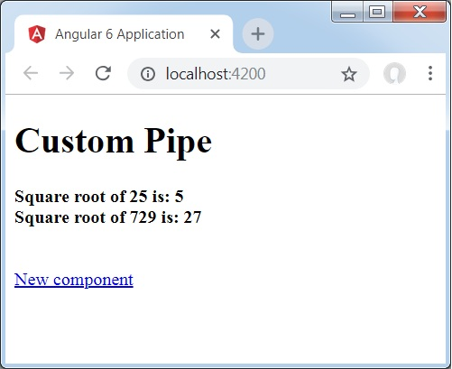
When a user clicks New component, you will see the following in the browser.
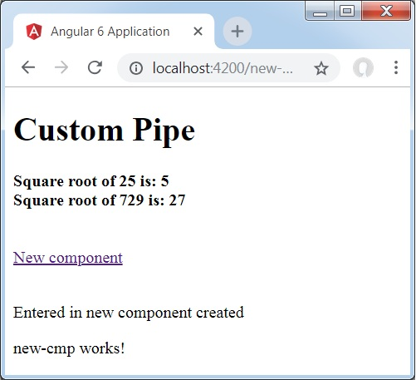
The url contains http://localhost:4200/new-cmp. Here, the new-cmp gets appended to the original url, which is the path given in the app.module.ts and the router-link in the app.component.html.
When a user clicks New component, the page is not refreshed and the contents are shown to the user without any reloading. Only a particular piece of the site code will be reloaded when clicked. This feature helps when we have heavy content on the page and needs to be loaded based on the user interaction. The feature also gives a good user experience as the page is not reloaded.

Angular 6 - Services
In this chapter, we will discuss the services in Angular 6.
We might come across a situation where we need some code to be used everywhere on the page. It can be for data connection that needs to be shared across components, etc. Services help us achieve that. With services, we can access methods and properties across other components in the entire project.
To create a service, we need to make use of the command line. The command for the same is −
C:\projectA6\Angular6App>ng g service myservice
CREATE src/app/myservice.service.spec.ts (392 bytes)
CREATE src/app/myservice.service.ts (138 bytes)
The files are created in the app folder as follows −
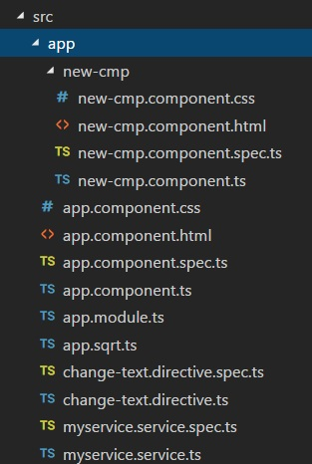
Following are the files created at the bottom - myservice.service.specs.ts and myservice.service.ts.
myservice.service.ts
import { Injectable } from '@angular/core';
@Injectable()
export class MyserviceService {
constructor() { }
}
Here, the Injectable module is imported from the @angular/core. It contains the @Injectable method and a class called MyserviceService. We will create our service function in this class.
Before creating a new service, we need to include the service created in the main parent app.module.ts.
import { BrowserModule } from '@angular/platform-browser';
import { NgModule } from '@angular/core';
import { RouterModule} from '@angular/router';
import { AppComponent } from './app.component';
import { MyserviceService } from './myservice.service';
import { NewCmpComponent } from './new-cmp/new-cmp.component';
import { ChangeTextDirective } from './change-text.directive';
import { SqrtPipe } from './app.sqrt';
@NgModule({
declarations: [
SqrtPipe,
AppComponent,
NewCmpComponent,
ChangeTextDirective
],
imports: [
BrowserModule,
RouterModule.forRoot([
{
path: 'new-cmp',
component: NewCmpComponent
}
])
],
providers: [MyserviceService],
bootstrap: [AppComponent]
})
export class AppModule { }
We have imported the Service with the class name and the same class is used in the providers. Let us now switch back to the service class and create a service function.
In the service class, we will create a function which will display today�s date. We can use the same function in the main parent component app.component.ts and also in the new component new-cmp.component.ts that we created in the previous chapter.
Let us now see how the function looks in the service and how to use it in components.
import { Injectable } from '@angular/core';
@Injectable()
export class MyserviceService {
constructor() { }
showTodayDate() {
let ndate = new Date();
return ndate;
}
}
In the above service file, we have created a function showTodayDate. Now we will return the new Date () created. Let us see how we can access this function in the component class.
app.component.ts
import { Component } from '@angular/core';
import { MyserviceService } from './myservice.service';
@Component({
selector: 'app-root',
templateUrl: './app.component.html',
styleUrls: ['./app.component.css']
})
export class AppComponent {
title = 'Angular 6 Project!';
todaydate;
constructor(private myservice: MyserviceService) {}
ngOnInit() {
this.todaydate = this.myservice.showTodayDate();
}
}
The ngOnInit function gets called by default in any component created. The date is fetched from the service as shown above. To fetch more details of the service, we need to first include the service in the component ts file.
We will display the date in the .html file as shown below −
{{todaydate}}
<app-new-cmp></app-new-cmp>
// data to be displayed to user from the new component class.
Let us now see how to use the service in the new component created.
import { Component, OnInit } from '@angular/core';
import { MyserviceService } from './../myservice.service';
@Component({
selector: 'app-new-cmp',
templateUrl: './new-cmp.component.html',
styleUrls: ['./new-cmp.component.css']
})
export class NewCmpComponent implements OnInit {
todaydate;
newcomponent = "Entered in new component created";
constructor(private myservice: MyserviceService) {}
ngOnInit() {
this.todaydate = this.myservice.showTodayDate();
}
}
In the new component that we have created, we need to first import the service that we want and access the methods and properties of the same. Please see the code highlighted. The todaydate is displayed in the component html as follows −
<p>
{{newcomponent}}
</p>
<p>
Today's Date : {{todaydate}}
</p>
The selector of the new component is used in the app.component.html file. The contents from the above html file will be displayed in the browser as shown below −
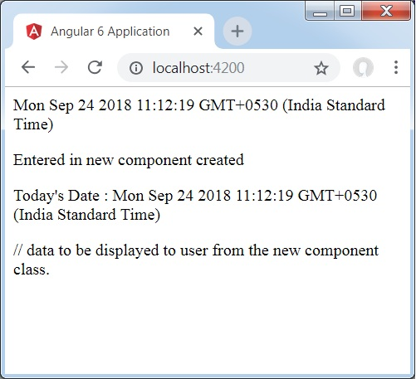
If you change the property of the service in any component, the same is changed in other components too. Let us now see how this works.
We will define one variable in the service and use it in the parent and the new component. We will again change the property in the parent component and will see if the same is changed in the new component or not.
In myservice.service.ts, we have created a property and used the same in other parent and new component.
import { Injectable } from '@angular/core';
@Injectable()
export class MyserviceService {
serviceproperty = "Service Created";
constructor() { }
showTodayDate() {
let ndate = new Date();
return ndate;
}
}
Let us now use the serviceproperty variable in other components. In app.component.ts, we are accessing the variable as follows −
import { Component } from '@angular/core';
import { MyserviceService } from './myservice.service';
@Component({
selector: 'app-root',
templateUrl: './app.component.html',
styleUrls: ['./app.component.css']
})
export class AppComponent {
title = 'Angular 4 Project!';
todaydate;
componentproperty;
constructor(private myservice: MyserviceService) {}
ngOnInit() {
this.todaydate = this.myservice.showTodayDate();
console.log(this.myservice.serviceproperty);
this.myservice.serviceproperty = "component created"; // value is changed.
this.componentproperty = this.myservice.serviceproperty;
}
}
We will now fetch the variable and work on the console.log. In the next line, we will change the value of the variable to "component created". We will do the same in new-cmp.component.ts.
import { Component, OnInit } from '@angular/core';
import { MyserviceService } from './../myservice.service';
@Component({
selector: 'app-new-cmp',
templateUrl: './new-cmp.component.html',
styleUrls: ['./new-cmp.component.css']
})
export class NewCmpComponent implements OnInit {
todaydate;
newcomponentproperty;
newcomponent = "Entered in newcomponent";
constructor(private myservice: MyserviceService) {}
ngOnInit() {
this.todaydate = this.myservice.showTodayDate();
this.newcomponentproperty = this.myservice.serviceproperty;
}
}
In the above component, we are not changing anything but directly assigning the property to the component property.
Now when you execute it in the browser, the service property will be changed since the value of it is changed in app.component.ts and the same will be displayed for the new-cmp.component.ts.
Also check the value in the console before it is changed.
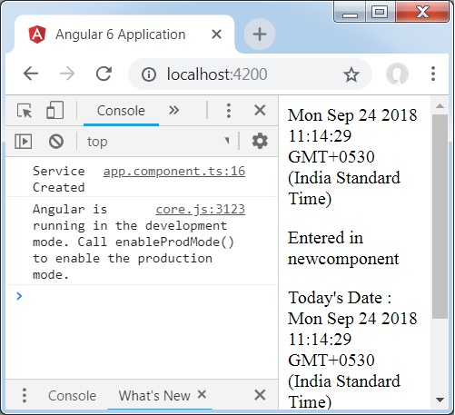

Angular 6 - Http Service
Http Service will help us fetch external data, post to it, etc. We need to import the http module to make use of the http service. Let us consider an example to understand how to make use of the http service.
To start using the http service, we need to import the module in app.module.ts as shown below −
import { BrowserModule } from '@angular/platform-browser';
import { NgModule } from '@angular/core';
import { BrowserAnimationsModule } from '@angular/platform-browser/animations';
import { HttpModule } from '@angular/http';
import { AppComponent } from './app.component';
@NgModule({
declarations: [
AppComponent
],
imports: [
BrowserModule,
BrowserAnimationsModule,
HttpModule
],
providers: [],
bootstrap: [AppComponent]
})
export class AppModule { }
If you see the highlighted code, we have imported the HttpModule from @angular/http and the same is also added in the imports array.
Let us now use the http service in the app.component.ts.
import { Component } from '@angular/core';
import { Http } from '@angular/http';
import 'rxjs/add/operator/map';
@Component({
selector: 'app-root',
templateUrl: './app.component.html',
styleUrls: ['./app.component.css']
})
export class AppComponent {
constructor(private http: Http) { }
ngOnInit() {
this.http.get("http://jsonplaceholder.typicode.com/users").
map((response) ⇒ response.json()).
subscribe((data) ⇒ console.log(data))
}
}
Let us understand the code highlighted above. We need to import http to make use of the service, which is done as follows −
import { Http } from '@angular/http';
In the class AppComponent, a constructor is created and the private variable http of type Http. To fetch the data, we need to use the get API available with http as follows
this.http.get();
It takes the url to be fetched as the parameter as shown in the code.
We will use the test url − https://jsonplaceholder.typicode.com/users to fetch the json data. Two operations are performed on the fetched url data map and subscribe. The Map method helps to convert the data to json format. To use the map, we need to import the same as shown below −
import {map} from 'rxjs/operators';
Once the map is done, the subscribe will log the output in the console as shown in the browser −
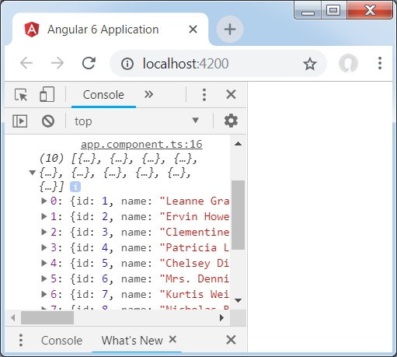
If you see, the json objects are displayed in the console. The objects can be displayed in the browser too.
For the objects to be displayed in the browser, update the codes in app.component.html and app.component.ts as follows −
import { Component } from '@angular/core';
import { Http } from '@angular/http';
import { map} from 'rxjs/operators';
@Component({
selector: 'app-root',
templateUrl: './app.component.html',
styleUrls: ['./app.component.css']
})
export class AppComponent {
constructor(private http: Http) { }
httpdata;
ngOnInit() {
this.http.get("http://jsonplaceholder.typicode.com/users")
.pipe(map((response) => response.json()))
.subscribe((data) => this.displaydata(data));
}
displaydata(data) {this.httpdata = data;}
}
In app.component.ts, using the subscribe method we will call the display data method and pass the data fetched as the parameter to it.
In the display data method, we will store the data in a variable httpdata. The data is displayed in the browser using for over this httpdata variable, which is done in the app.component.html file.
<ul *ngFor = "let data of httpdata">
<li>Name : {{data.name}} Address: {{data.address.city}}</li>
</ul>
The json object is as follows −
{
"id": 1,
"name": "Leanne Graham",
"username": "Bret",
"email": "Sincere@april.biz",

"address": {
"street": "Kulas Light",
"suite": "Apt. 556",
"city": "Gwenborough",
"zipcode": "92998-3874",
"geo": {
"lat": "-37.3159",
"lng": "81.1496"
}
},

"phone": "1-770-736-8031 x56442",
"website": "hildegard.org",
"company": {
"name": "Romaguera-Crona",
"catchPhrase": "Multi-layered client-server neural-net",
"bs": "harness real-time e-markets"
}
}
The object has properties such as id, name, username, email, and address that internally has street, city, etc. and other details related to phone, website, and company. Using the for loop, we will display the name and the city details in the browser as shown in the app.component.html file.
This is how the display is shown in the browser −
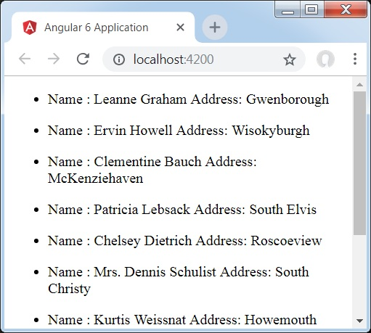
Let us now add the search parameter, which will filter based on specific data. We need to fetch the data based on the search param passed.
Following are the changes done in app.component.html and app.component.ts files −

app.component.ts
import { Component } from '@angular/core';
import { Http } from '@angular/http';
import { map} from 'rxjs/operators';
@Component({
selector: 'app-root',
templateUrl: './app.component.html',
styleUrls: ['./app.component.css']
})
export class AppComponent {
constructor(private http: Http) { }
httpdata;
name;
searchparam = 2;
ngOnInit() {
this.http.get("http://jsonplaceholder.typicode.com/users?id="+this.searchparam)
.pipe(map((response) => response.json()))
.subscribe((data) => this.displaydata(data));
}
displaydata(data) {this.httpdata = data;}
}
For the get api, we will add the search param id = this.searchparam. The searchparam is equal to 2. We need the details of id = 2 from the json file.
This is how the browser is displayed −
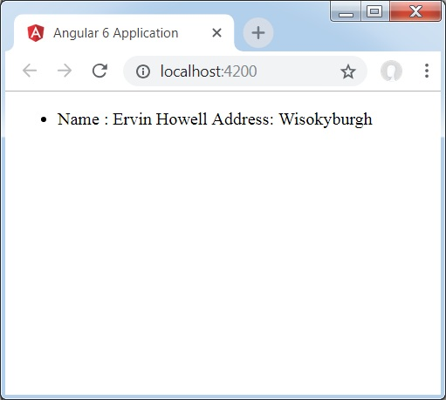
We have consoled the data in the browser, which is received from the http. The same is displayed in the browser console. The name from the json with id = 2 is displayed in the browser.

Angular 6 - Http Client
HttpClient is introduced in Angular 6 and it will help us fetch external data, post to it, etc. We need to import the http module to make use of the http service. Let us consider an example to understand how to make use of the http service.
To start using the http service, we need to import the module in app.module.ts as shown below −
import { BrowserModule } from '@angular/platform-browser';
import { NgModule } from '@angular/core';
import { BrowserAnimationsModule } from '@angular/platform-browser/animations';
import { HttpClientModule } from '@angular/common/http';
import { AppComponent } from './app.component';
@NgModule({
declarations: [
AppComponent
],
imports: [
BrowserModule,
BrowserAnimationsModule,
HttpClientModule
],
providers: [],
bootstrap: [AppComponent]
})
export class AppModule { }
If you see the highlighted code, we have imported the HttpClientModule from @angular/common/http and the same is also added in the imports array.
Let us now use the http client in the app.component.ts.
import { Component } from '@angular/core';
import { HttpClient } from '@angular/common/http';
@Component({
selector: 'app-root',
templateUrl: './app.component.html',
styleUrls: ['./app.component.css']
})
export class AppComponent {
constructor(private http: HttpClient) { }
ngOnInit() {
this.http.get("http://jsonplaceholder.typicode.com/users").
subscribe((data) ⇒ console.log(data))
}
}
Let us understand the code highlighted above. We need to import http to make use of the service, which is done as follows −
import { HttpClient } from '@angular/common/http';
In the class AppComponent, a constructor is created and the private variable http of type Http. To fetch the data, we need to use the get API available with http as follows
this.http.get();
It takes the url to be fetched as the parameter as shown in the code.
We will use the test url − https://jsonplaceholder.typicode.com/users to fetch the json data. The subscribe will log the output in the console as shown in the browser −
If you see, the json objects are displayed in the console. The objects can be displayed in the browser too.
For the objects to be displayed in the browser, update the codes in app.component.html and app.component.ts as follows −
import { Component } from '@angular/core';
import { HttpClient } from '@angular/common/http';
@Component({
selector: 'app-root',
templateUrl: './app.component.html',
styleUrls: ['./app.component.css']
})
export class AppComponent {
constructor(private http: HttpClient) { }
httpdata;
ngOnInit() {
this.http.get("http://jsonplaceholder.typicode.com/users")
.subscribe((data) => this.displaydata(data));
}
displaydata(data) {this.httpdata = data;}
}
In app.component.ts, using the subscribe method we will call the display data method and pass the data fetched as the parameter to it.
In the display data method, we will store the data in a variable httpdata. The data is displayed in the browser using for over this httpdata variable, which is done in the app.component.html file.
<ul *ngFor = "let data of httpdata">
<li>Name : {{data.name}} Address: {{data.address.city}}</li>
</ul>
The json object is as follows −
{
"id": 1,
"name": "Leanne Graham",
"username": "Bret",
"email": "Sincere@april.biz",

"address": {
"street": "Kulas Light",
"suite": "Apt. 556",
"city": "Gwenborough",
"zipcode": "92998-3874",
"geo": {
"lat": "-37.3159",
"lng": "81.1496"
}
},

"phone": "1-770-736-8031 x56442",
"website": "hildegard.org",
"company": {
"name": "Romaguera-Crona",
"catchPhrase": "Multi-layered client-server neural-net",
"bs": "harness real-time e-markets"
}
}
The object has properties such as id, name, username, email, and address that internally has street, city, etc. and other details related to phone, website, and company. Using the for loop, we will display the name and the city details in the browser as shown in the app.component.html file.
This is how the display is shown in the browser −
Let us now add the search parameter, which will filter based on specific data. We need to fetch the data based on the search param passed.
Following are the changes done in app.component.html and app.component.ts files −

app.component.ts
import { Component } from '@angular/core';
import { HttpClient } from '@angular/common/http';
@Component({
selector: 'app-root',
templateUrl: './app.component.html',
styleUrls: ['./app.component.css']
})
export class AppComponent {
constructor(private http: HttpClient) { }
httpdata;
name;
searchparam = 2;
ngOnInit() {
this.http.get("http://jsonplaceholder.typicode.com/users?id="+this.searchparam)
.subscribe((data) => this.displaydata(data));
}
displaydata(data) {this.httpdata = data;}
}
For the get api, we will add the search param id = this.searchparam. The searchparam is equal to 2. We need the details of id = 2 from the json file.
This is how the browser is displayed −
We have consoled the data in the browser, which is received from the http. The same is displayed in the browser console. The name from the json with id = 2 is displayed in the browser.

Angular 6 - Forms
In this chapter, we will see how forms are used in Angular 6. We will discuss two ways of working with forms - template driven form and model driven forms.

Template Driven Form
With a template driven form, most of the work is done in the template; and with the model driven form, most of the work is done in the component class.
Let us now consider working on the Template driven form. We will create a simple login form and add the email id, password and submit the button in the form. To start with, we need to import to FormsModule from @angular/core which is done in app.module.ts as follows −
import { BrowserModule } from '@angular/platform-browser';
import { NgModule } from '@angular/core';
import { RouterModule} from '@angular/router';
import { HttpModule } from '@angular/http';
import { FormsModule } from '@angular/forms';
import { AppComponent } from './app.component';
import { MyserviceService } from './myservice.service';
import { NewCmpComponent } from './new-cmp/new-cmp.component';
import { ChangeTextDirective } from './change-text.directive';
import { SqrtPipe } from './app.sqrt';
@NgModule({
declarations: [
SqrtPipe,
AppComponent,
NewCmpComponent,
ChangeTextDirective
],
imports: [
BrowserModule,
HttpModule,
FormsModule,
RouterModule.forRoot([
{path: 'new-cmp',component: NewCmpComponent}
])
],
providers: [MyserviceService],
bootstrap: [AppComponent]
})
export class AppModule { }
So in app.module.ts, we have imported the FormsModule and the same is added in the imports array as shown in the highlighted code.
Let us now create our form in the app.component.html file.
<form #userlogin = "ngForm" (ngSubmit) = "onClickSubmit(userlogin.value)" >
<input type = "text" name = "emailid" placeholder = "emailid" ngModel>
<br/>
<input type = "password" name = "passwd" placeholder = "passwd" ngModel>
<br/>
<input type = "submit" value = "submit">
</form>
We have created a simple form with input tags having email id, password and the submit button. We have assigned type, name, and placeholder to it.
In template driven forms, we need to create the model form controls by adding the ngModel directive and the name attribute. Thus, wherever we want Angular to access our data from forms, add ngModel to that tag as shown above. Now, if we have to read the emailid and passwd, we need to add the ngModel across it.
If you see, we have also added the ngForm to the #userlogin. The ngForm directive needs to be added to the form template that we have created. We have also added function onClickSubmit and assigned userlogin.value to it.
Let us now create the function in the app.component.ts and fetch the values entered in the form.
import { Component } from '@angular/core';
import { MyserviceService } from './myservice.service';
@Component({
selector: 'app-root',
templateUrl: './app.component.html',
styleUrls: ['./app.component.css']
})
export class AppComponent {
title = 'Angular 6 Project!';
todaydate;
componentproperty;
constructor(private myservice: MyserviceService) { }
ngOnInit() {
this.todaydate = this.myservice.showTodayDate();
}
onClickSubmit(data) {
alert("Entered Email id : " + data.emailid);
}
}
In the above app.component.ts file, we have defined the function onClickSubmit. When you click on the form submit button, the control will come to the above function.
This is how the browser is displayed −
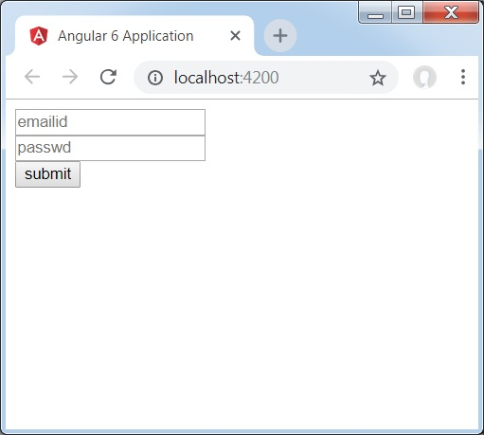
The form looks like as shown below. Let us enter the data in it and in the submit function, the email id is already entered.
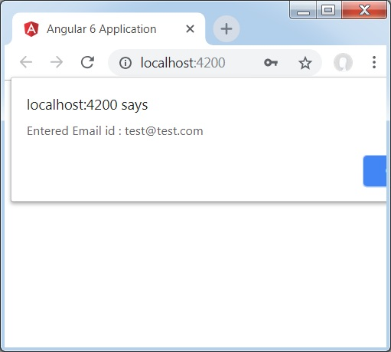
The email id is displayed at the bottom as shown in the above screenshot.

Model Driven Form
In the model driven form, we need to import the ReactiveFormsModule from @angular/forms and use the same in the imports array.
There is a change which goes in app.module.ts.
import { BrowserModule } from '@angular/platform-browser';
import { NgModule } from '@angular/core';
import { RouterModule} from '@angular/router';
import { HttpModule } from '@angular/http';
import { ReactiveFormsModule } from '@angular/forms';
import { AppComponent } from './app.component';
import { MyserviceService } from './myservice.service';
import { NewCmpComponent } from './new-cmp/new-cmp.component';
import { ChangeTextDirective } from './change-text.directive';
import { SqrtPipe } from './app.sqrt';
@NgModule({
declarations: [
SqrtPipe,
AppComponent,
NewCmpComponent,
ChangeTextDirective
],
imports: [
BrowserModule,
HttpModule,
ReactiveFormsModule,
RouterModule.forRoot([
{
path: 'new-cmp',
component: NewCmpComponent
}
])
],
providers: [MyserviceService],
bootstrap: [AppComponent]
})
export class AppModule { }
In app.component.ts, we need to import a few modules for the model driven form. For example, import { FormGroup, FormControl } from '@angular/forms'.
import { Component } from '@angular/core';
import { MyserviceService } from './myservice.service';
import { FormGroup, FormControl } from '@angular/forms';
@Component({
selector: 'app-root',
templateUrl: './app.component.html',
styleUrls: ['./app.component.css']
})
export class AppComponent {
title = 'Angular 6 Project!';
todaydate;
componentproperty;
emailid;
formdata;
constructor(private myservice: MyserviceService) { }
ngOnInit() {
this.todaydate = this.myservice.showTodayDate();
this.formdata = new FormGroup({
emailid: new FormControl("angular@gmail.com"),
passwd: new FormControl("abcd1234")
});
}
onClickSubmit(data) {this.emailid = data.emailid;}
}
The variable formdata is initialized at the start of the class and the same is initialized with FormGroup as shown above. The variables emailid and passwd are initialized with default values to be displayed in the form. You can keep it blank in case you want to.
This is how the values will be seen in the form UI.
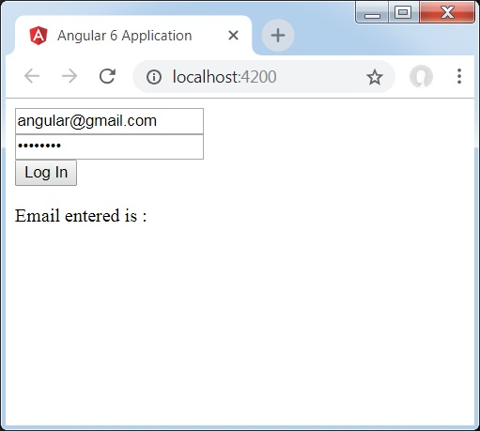
We have used formdata to initialize the form values; we need to use the same in the form UI app.component.html.
<div>
<form [formGroup] = "formdata" (ngSubmit) = "onClickSubmit(formdata.value)" >
<input type = "text" class = "fortextbox" name = "emailid" placeholder = "emailid"
formControlName="emailid">
<br/>

<input type = "password" class = "fortextbox" name="passwd"
placeholder = "passwd" formControlName = "passwd">
<br/>

<input type = "submit" class = "forsubmit" value = "Log In">
</form>
</div>
<p>
Email entered is : {{emailid}}
</p>
In the .html file, we have used formGroup in square bracket for the form; for example, [formGroup]="formdata". On submit, the function is called onClickSubmit for which formdata.value is passed.
The input tag formControlName is used. It is given a value that we have used in the app.component.ts file.
On clicking submit, the control will pass to the function onClickSubmit, which is defined in the app.component.ts file.
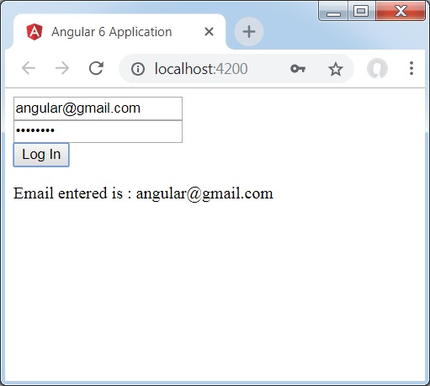
On clicking Login, the value will be displayed as shown in the above screenshot.

Form Validation
Let us now discuss form validation using model driven form. You can use the built-in form validation or also use the custom validation approach. We will use both the approaches in the form. We will continue with the same example that we created in one of our previous sections. With Angular 4, we need to import Validators from @angular/forms as shown below −
import { FormGroup, FormControl, Validators} from '@angular/forms'
Angular has built-in validators such as mandatory field, minlength, maxlength, and pattern. These are to be accessed using the Validators module.
You can just add validators or an array of validators required to tell Angular if a particular field is mandatory.
Let us now try the same on one of the input textboxes, i.e., email id. For the email id, we have added the following validation parameters −
- Required
- Pattern matching
This is how a code undergoes validation in app.component.ts.
import { Component } from '@angular/core';
import { FormGroup, FormControl, Validators} from '@angular/forms';
@Component({
selector: 'app-root',
templateUrl: './app.component.html',
styleUrls: ['./app.component.css']
})
export class AppComponent {
title = 'Angular 6 Project!';
todaydate;
componentproperty;
emailid;
formdata;
ngOnInit() {
this.formdata = new FormGroup({
emailid: new FormControl("", Validators.compose([
Validators.required,
Validators.pattern("[^ @]*@[^ @]*")
])),
passwd: new FormControl("")
});
}
onClickSubmit(data) {this.emailid = data.emailid;}
}
In Validators.compose, you can add the list of things you want to validate on the input field. Right now, we have added the required and the pattern matching parameters to take only valid email.
In the app.component.html, the submit button is disabled if any of the form inputs are not valid. This is done as follows −
<div>
<form [formGroup] = "formdata" (ngSubmit) = "onClickSubmit(formdata.value)" >
<input type = "text" class = "fortextbox" name = "emailid" placeholder = "emailid"
formControlName = "emailid">
<br/>
<input type = "password" class = "fortextbox" name = "passwd"
placeholder = "passwd" formControlName = "passwd">
<br/>
<input type = "submit" [disabled] = "!formdata.valid" class = "forsubmit"
value = "Log In">
</form>
</div>
<p>
Email entered is : {{emailid}}
</p>
For the submit button, we have added disabled in the square bracket, which is given value - !formdata.valid. Thus, if the formdata.valid is not valid, the button will remain disabled and the user will not be able to submit it.
Let us see the how this works in the browser −
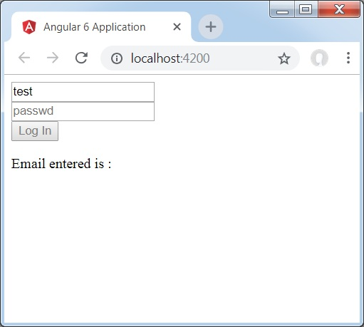
In the above case, the email id entered is invalid, hence the login button is disabled. Let us now try entering the valid email id and see the difference.
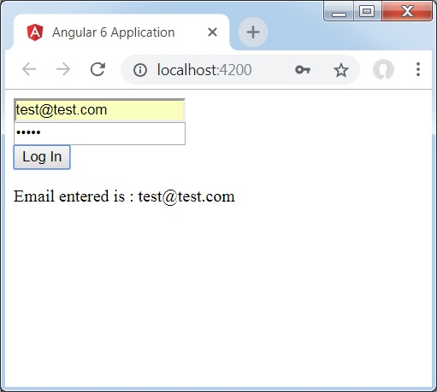
Now, the email id entered is valid. Thus, we can see the login button is enabled and the user will be able to submit it. With this, the email id entered is displayed at the bottom.
Let us now try custom validation with the same form. For custom validation, we can define our own custom function and add the required details in it. We will now see an example for the same.
import { Component } from '@angular/core';
import { FormGroup, FormControl, Validators} from '@angular/forms';
@Component({
selector: 'app-root',
templateUrl: './app.component.html',
styleUrls: ['./app.component.css']
})
export class AppComponent {
title = 'Angular 6 Project!';
todaydate;
componentproperty;
emailid;
formdata;
ngOnInit() {
this.formdata = new FormGroup({
emailid: new FormControl("", Validators.compose([
Validators.required,
Validators.pattern("[^ @]*@[^ @]*")
])),
passwd: new FormControl("", this.passwordvalidation)
});
}
passwordvalidation(formcontrol) {
if (formcontrol.value.length < 5) {
return {"passwd" : true};
}
}
onClickSubmit(data) {this.emailid = data.emailid;}
}
In the above example, we have created a function password validation and the same is used in a previous section in the formcontrol − passwd: new FormControl("", this.passwordvalidation).
In the function that we have created, we will check if the length of the characters entered is appropriate. If the characters are less than five, it will return with the passwd true as shown above - return {"passwd" : true};. If the characters are more than five, it will consider it as valid and the login will be enabled.
Let us now see how this is displayed in the browser −
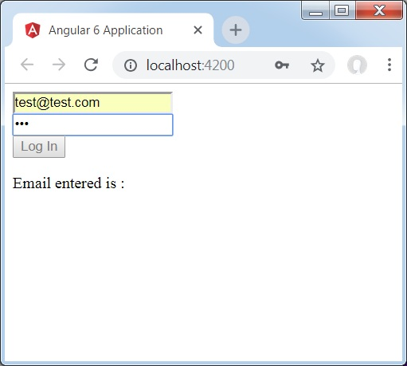
We have entered only three characters in the password and the login is disabled. To enable login, we need more than five characters. Let us now enter a valid length of characters and check.
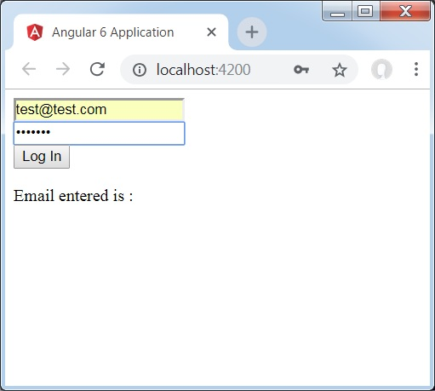
The login is enabled as both the email id and the password are valid. The email is displayed at the bottom as we log in.

Angular 6 - Animations
Animations add a lot of interaction between the html elements. Animation was also available with Angular2. The difference with Angular 6 is that animation is no more a part of the @angular/core library, but is a separate package that needs to be imported in app.module.ts.
To start with, we need to import the library as follows −
import { BrowserAnimationsModule } from '@angular/platform-browser/animations';
The BrowserAnimationsModule needs to be added to the import array in app.module.ts as shown below −
app.module.ts
import { BrowserModule } from '@angular/platform-browser';
import { NgModule } from '@angular/core';
import { BrowserAnimationsModule } from '@angular/platform-browser/animations';
import { AppComponent } from './app.component';
@NgModule({
declarations: [
AppComponent
],
imports: [
BrowserModule,
BrowserAnimationsModule
],
providers: [],
bootstrap: [AppComponent]
})
export class AppModule { }
In app.component.html, we have added the html elements, which are to be animated.
<div>
<button (click) = "animate()">Click Me</button>
<div [@myanimation] = "state" class = "rotate">
<img src = "assets/images/img.png" width = "100" height = "100">
</div>
</div>
For the main div, we have added a button and a div with an image. There is a click event for which the animate function is called. And for the div, the @myanimation directive is added and given the value as state.
Let us now see the app.component.ts where the animation is defined.
import { Component } from '@angular/core';
import { trigger, state, style, transition, animate } from '@angular/animations';
@Component({
selector: 'app-root',
templateUrl: './app.component.html',
styleUrls: ['./app.component.css'],
styles:[`
div{
margin: 0 auto;
text-align: center;
width:200px;
}
.rotate{
width:100px;
height:100px;
border:solid 1px red;
}
`],
animations: [
trigger('myanimation',[
state('smaller',style({
transform : 'translateY(100px)'
})),
state('larger',style({
transform : 'translateY(0px)'
})),
transition('smaller <=> larger',animate('300ms ease-in'))
])
]
})
export class AppComponent {
state: string = "smaller";
animate() {
this.state= this.state == 'larger' ? 'smaller' : 'larger';
}
}
We have to import the animation function that is to be used in the .ts file as shown above.
import { trigger, state, style, transition, animate } from '@angular/animations';
Here we have imported trigger, state, style, transition, and animate from @angular/animations.
Now, we will add the animations property to the @Component () decorator −
animations: [
trigger('myanimation',[
state('smaller',style({
transform : 'translateY(100px)'
})),
state('larger',style({
transform : 'translateY(0px)'
})),
transition('smaller <=> larger',animate('300ms ease-in'))
])
]
Trigger defines the start of the animation. The first param to it is the name of the animation to be given to the html tag to which the animation needs to be applied. The second param are the functions we have imported - state, transition, etc.
The state function involves the animation steps, which the element will transition between. Right now we have defined two states, smaller and larger. For smaller state, we have given the style transform:translateY(100px) and transform:translateY(100px).
Transition function adds animation to the html element. The first argument takes the states, i.e., start and end; the second argument accepts the animate function. The animate function allows you to define the length, delay, and easing of a transition.
Let us now see the .html file to see how the transition function works
<div>
<button (click) = "animate()">Click Me</button>
<div [@myanimation] = "state" class="rotate">
<img src = "assets/images/img.png" width = "100" height = "100">
</div>
</div>
There is a style property added in the @component directive, which centrally aligns the div. Let us consider the following example to understand the same −
styles:[`
div{
margin: 0 auto;
text-align: center;
width:200px;
}
.rotate{
width:100px;
height:100px;
border:solid 1px red;
}
`],
Here, a special character [``] is used to add styles to the html element, if any. For the div, we have given the animation name defined in the app.component.ts file.
On the click of a button it calls the animate function, which is defined in the app.component.ts file as follows −
export class AppComponent {
state: string = "smaller";
animate() {
this.state= this.state == �larger�? 'smaller' : 'larger';
}
}
The state variable is defined and is given the default value as smaller. The animate function changes the state on click. If the state is larger, it will convert to smaller; and if smaller, it will convert to larger.
This is how the output in the browser (http://localhost:4200/) will look like −
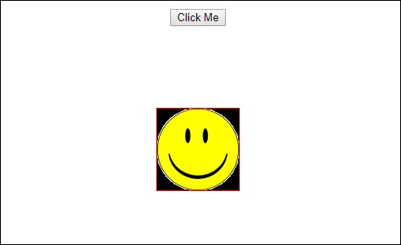
Upon clicking the Click Me button, the position of the image is changed as shown in the following screenshot −
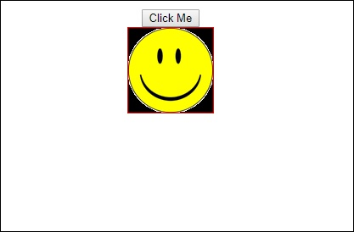
The transform function is applied in the y direction, which is changed from 0 to 100px when the Click Me button is clicked. The image is stored in the assets/images folder.

Angular interview Questions
So you have learned the JavaScript programming language and you want to move on to learning JavaScript frameworks since, the modern industry requires developers to know various in-demand frameworks.
By learning and understanding various in-demand frameworks, you not only improve your knowledge but also give yourself a better chance of bagging a job.
In this article, we are going to learn about one of the most popular frameworks, Angular. We are going to understand the fundamentals and building blocks of Angular by answering the most frequently asked interview questions.
1. Why were client-side frameworks like Angular introduced?
Back in the day, web developers used VanillaJS and jQuery to develop dynamic websites but, as the logic of one's website grew, the code became more and more tedious to maintain. For applications that use complex logic, developers had to put in extra effort to maintain separation of concerns for the app. Also, jQuery did not provide facilities for data handling across views.
For tackling the above problems, client-side frameworks like Angular came into the picture, which made life easier for the developers by handling separation of concerns and dividing code into smaller bits of information (In the case of Angular, called Components).
Client-side frameworks allow one to develop advanced web applications like Single-Page-Application. Not that we cannot develop SPAs using VanillaJS, but by doing so, the development process becomes slower.
2. How does an Angular application work?
Every Angular app consists of a file named angular.json. This file will contain all the configurations of the app. While building the app, the builder looks at this file to find the entry point of the application. Following is an image of the angular.json file:

"build": {
"builder": "@angular-devkit/build-angular:browser",
"options": {
"outputPath": "dist/angular-starter",
"index": "src/index.html",
"main": "src/main.ts",
"polyfills": "src/polyfills.ts",
"tsConfig": "tsconfig.app.json",
"aot": false,
"assets": [
"src/favicon.ico",
"src/assets"
],
"styles": [
"./node_modules/@angular/material/prebuilt-themes/deeppurple-amber.css",
"src/style.css"
]
}
}

Inside the build section, the main property of the options object defines the entry point of the application which in this case is main.ts.
The main.ts file creates a browser environment for the application to run, and, along with this, it also calls a function called bootstrapModule, which bootstraps the application. These two steps are performed in the following order inside the main.ts file:
import { platformBrowserDynamic } from '@angular/platform-browser-dynamic';

platformBrowserDynamic().bootstrapModule(AppModule)
In the above line of code, AppModule is getting bootstrapped.
The AppModule is declared in the app.module.ts file. This module contains declarations of all the components.
Below is an example of app.module.ts file:

import { BrowserModule } from '@angular/platform-browser';
import { NgModule } from '@angular/core';
import { AppComponent } from './app.component';

@NgModule({
declarations: [
AppComponent
],
imports: [
BrowserModule
],
providers: [],
entryComponents: [],
bootstrap: [AppComponent]
})
export class AppModule { }

As one can see in the above file, AppComponent is getting bootstrapped.
This component is defined in app.component.ts file. This file interacts with the webpage and serves data to it.
Below is an example of app.component.ts file:

import { Component } from '@angular/core';

@Component({
selector: 'app-root',
templateUrl: './app.component.html',
styleUrls: ['./app.component.css']
})
export class AppComponent {
title = 'angular';
}

Each component is declared with three properties:
1. Selector - used for accessing the component
2. Template/TemplateURL - contains HTML of the component
3. StylesURL - contains component-specific stylesheets
After this, Angular calls the index.html file. This file consequently calls the root component that is app-root. The root component is defined in app.component.ts.
This is how the index.html file looks:

<!doctype html>
<html lang="en">
<head>
<meta charset="utf-8">
<title>Angular</title>
<base href="/">
<meta name="viewport" content="width=device-width, initial-scale=1">
</head>
<body>
<app-root></app-root>
</body>
</html>

The HTML template of the root component is displayed inside the <app-root> tags.
This is how every angular application works.
3. What are some of the advantages of Angular over other frameworks?
• Features that are provided out of the box - Angular provides a number of built-in features like,routing, state management, rxjs library and http servicesstraight out of the box. This means that one does not need tolook for the above stated features separately. They are allprovided with angular.
• Declarative UI - Angular uses HTML to render the UI of an application. HTML isa declarative language and is much easier to use than JavaScript.
• Long-term Google support - Google announced Long-term support for Angular. This means that Google plans to stick with Angular and further scale up its ecosystem.
4. List out differences between AngularJS and Angular
Architecture
AngularJS uses MVC or Model-View-Controller architecture, where the Model contains the business logic, Controller processes information and View shows the information present in the Model.
Angular replaces controllers with Components. Components are nothing but directives with a predefined template.
Language
AngularJS uses JavaScript language, which is a dynamically typed language.
Angular uses TypeScript language, which is a statically typed language and is a superset of JavaScript. By using statically typed language, Angular provides better performance while developing larger applications.
Mobile Support
AngularJS does not provide mobile support.
Angular is supported by all popular mobile browsers.
Structure
While developing larger applications, the process of maintaining code becomes tedious in the case of AngularJS.
In the case of Angular, it is easier to maintain code for larger applications as it provides a better structure.
Expression Syntax
While developing an AngularJS application, a developer needs to remember the correct ng-directive for binding an event, or a property. Whereas in Angular, property binding is done using "[ ]" attribute and event binding is done using "( )" attribute.
5. What is AOT compilation? What are the advantages of AOT?
Every Angular application consists of components and templates which the browser cannot understand. Therefore, all the Angular applications need to be compiled first before running inside the browser.
Angular provides two types of compilation:
• JIT(Just-in-Time) compilation
• AOT(Ahead-of-Time) compilation
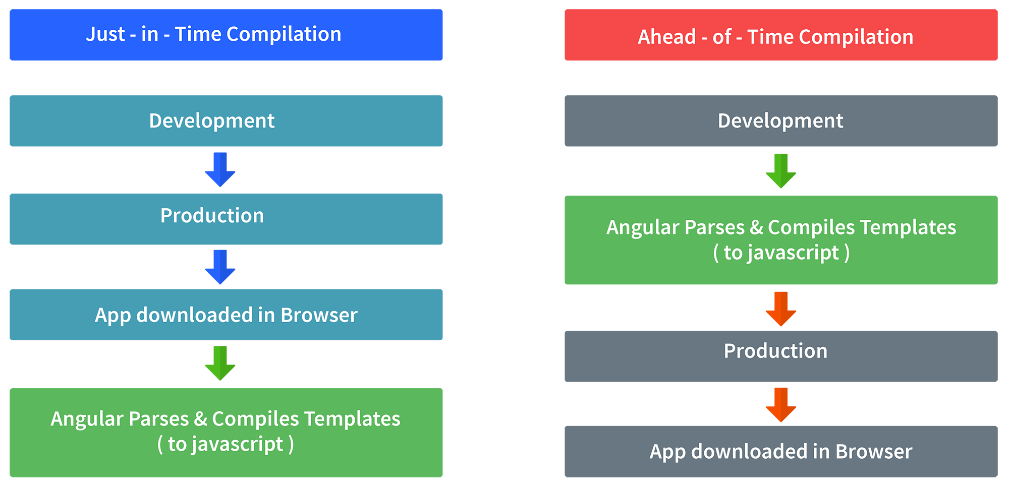
In JIT compilation, the application compiles inside the browser during runtime.
Whereas in the AOT compilation, the application compiles during the build time.
The advantages of using AOT compilation are:
• Since the application compiles before running inside the browser, the browser loads the executable code and renders the application immediately, which leads to faster rendering.
• In AOT compilation, the compiler sends the external HTML and CSS files along with the application, eliminating separate AJAX requests for those source files, which leads to fewer ajax requests.
• Developers can detect and handle errors during the building phase, which helps in minimizing errors.
• The AOT compiler adds HTML and templates into the JS files before they run inside the browser. Due to this, there are no extra HTML files to be read, which provide better security to the application.
By default, angular builds and serves the application using JIT compiler:
ng build
ng serve
For using AOT compiler following changes should be made:
ng build --aot
ng serve --aot
6. Explain Components, Modules and Services in Angular
For better understanding, I would like you to create an Angular application by running the following inside the command terminal:
ng new angularApp

The above command will create an angular application in the directory.
Next, let's move on to understand Components, Modules, and Services.
Components
In Angular, components are the basic building blocks, which control a part of the UI for any application.
A component is defined using the @Component decorator. Every component consists of three parts, the template which loads the view for the component, a stylesheet which defines the look and feel for the component, and a class that contains the business logic for the component.
For creating a component, inside the command terminal, navigate to the directory of the application created, and run the following command:
ng generate component test

Or
ng g c test

One can see the generated component inside src/app/test folder. The component will be defined inside test.component.ts and this is how it looks:

import { Component, OnInit } from '@angular/core';

@Component({
selector: 'app-test',
templateUrl: './test.component.html',
styleUrls: ['./test.component.css']
})
export lass TestComponent implements OnInit {

constructor() {}

ngOnInit() {
}
}

As we can see in the above image, our component is defined with @Component decorator.

Modules
A module is a place where we can group components, directives, services, and pipes. Module decides whether the components, directives, etc can be used by other modules, by exporting or hiding these elements. Every module is defined with a @NgModule decorator.
By default, modules are of two types:
• Root Module
• Feature ModuleEvery application can have only one root module whereas, it can have one or more feature modules.
A root module imports BrowserModule, whereas a feature module imports CommonModule.
In the application that we created before, one can see that the root module is defined inside app.module.ts and this is how it looks:

import { BrowserModule } from '@angular/platform-browser';
import { NgModule } from '@angular/core';

import { AppComponent } from './app.component';
import { TestComponent } from './test/text.component';

@NgModule({
declarations: [
AppComponent,
TestComponent
],
imports: [
BrowserModule
],
providers: [],
bootstrap: [AppComponent]
})
export class AppModule { }

We can see in the above image that the component we created earlier is already imported in the declarations array.
To create a feature module, run the following command:
ng g m test-module
The module is created inside the src/app/test-module/test-module.module.ts file:

import { NgModule } from '@angular/core';
import { CommonModule } from '@angular/common';

@NgModule({
declarations: [],
imports: [
CommonModule
]
})
export class TestModuleModule { }

As one can see, CommonModule is imported since this is a feature module.
Services Services are objects which get instantiated only once during the lifetime of an application. The main objective of a service is to share data, functions with different components of an Angular application.
A service is defined using a @Injectable decorator. A function defined inside a service can be invoked from any component or directive.
To create a service, run the following command:
ng g s test-service

The service will be created inside src/app/test-service.service.ts:

import { Injectable } from '@angular/core';

@Injectable({
providedIn: 'root'
})
export class TestServiceService {

constructor() { }

}

Any method/function defined inside the TestServiceService class can be directly used inside any component by just importing the service.
7. What are lifecycle hooks in Angular? Explain a few lifecycle hooks.
Every component in Angular has a lifecycle, different phases it goes through from the time of creation to the time it's destroyed. Angular provides hooks to tap into these phases and trigger changes at specific phases in a lifecycle.
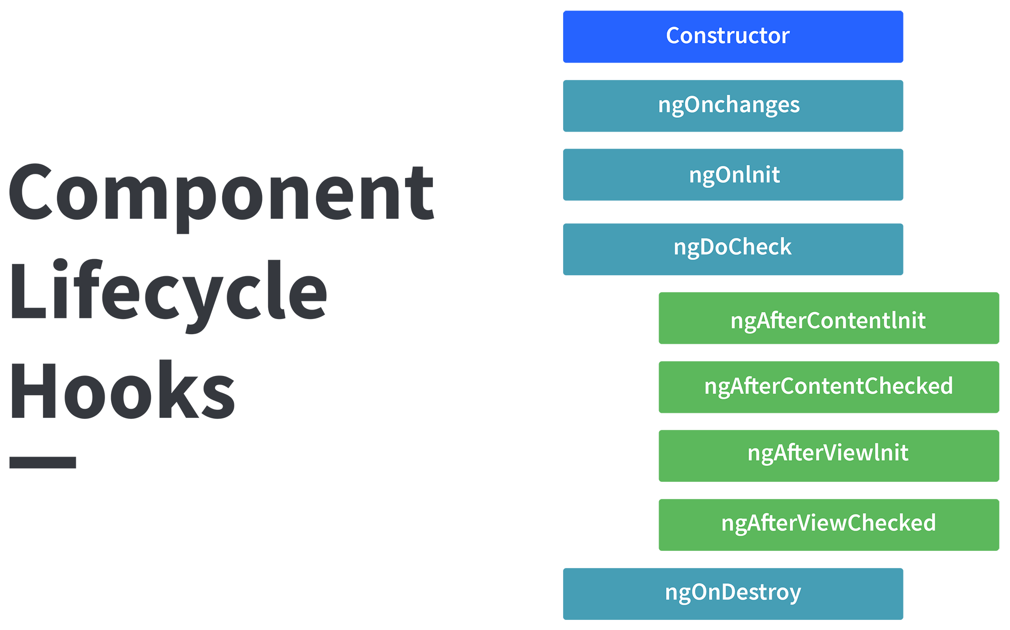
ngOnChanges( ) This hook/method is called before ngOnInit and whenever one or more input properties of the component changes.
This method/hook receives a SimpleChanges object which contains the previous and current values of the property.
ngOnInit( ) This hook gets called once, after the ngOnChanges hook.
It initializes the component and sets the input properties of the component.
ngDoCheck( ) It gets called after ngOnChanges and ngOnInit and is used to detect and act on changes that cannot be detected by Angular.
We can implement our change detection algorithm in this hook. ngAfterContentInit( ) It gets called after the first ngDoCheck hook. This hook responds after the content gets projected inside the component.
ngAfterContentChecked( ) It gets called after ngAfterContentInit and every subsequent ngDoCheck. It responds after the projected content is checked.
ngAfterViewInit( ) It responds after a component's view, or a child component's view is initialized.
ngAfterViewChecked( ) It gets called after ngAfterViewInit, and it responds after the component's view, or the child component's view is checked.
ngOnDestroy( ) It gets called just before Angular destroys the component. This hook can be used to clean up the code and detach event handlers.
Let’s understand how to use ngOnInit hook, since it’s the most oftenly used hook. If one has to process lot of data during component creation, it’s better to do it inside ngOnInit hook rather than the constructor:

import { Component, OnInit } from '@angular/core';

@Component({
selector: 'app-test',
templateUrl: './test.component.html',
styleUrls: ['./test.component.css']
})
export class TestComponent implements OnInit {
constructor() { }

ngOnInit() {
this.processData();
}

processData(){
// Do something..
}

}

As you can see we have imported OnInit but we have used ngOnInit function. This principle should be used with the rest of the hooks as well.
8. Explain string interpolation and property binding in Angular.
String interpolation and property binding are parts of data-binding in Angular.
Data-binding is a feature in angular, which provides a way to communicate between the component(Model) and its view(HTML template).
Data-binding can be done in two ways, one-way binding and two-way binding.
In Angular, data from the component can be inserted inside the HTML template. In one-way binding, any changes in the component will directly reflect inside the HTML template but, vice-versa is not possible. Whereas, it is possible in two-way binding.
String interpolation and property binding allow only one-way data binding.
String interpolation uses the double curly braces {{ }} to display data from the component. Angular automatically runs the expression written inside the curly braces, for example, {{ 2 + 2 }} will be evaluated by Angular and the output 4, will be displayed inside the HTML template. Using property binding, we can bind the DOM properties of an HTML element to a component's property. Property binding uses the square brackets [ ] syntax.
9. How are Angular expressions different from JavaScript expressions?
The first and perhaps, the biggest difference is that Angular expressions allow us to write JavaScript in HTML which is not the case when it comes to JavaScript expressions.
Next, Angular expressions are evaluated against a local scope object whereas JavaScript expressions against global window object. Let's understand that better with an example :
Consider the following component named test:

import { Component, OnInit } from '@angular/core';

@Component({
selector: 'app-test',
template: `
<h4>{{message}}</h4>
`,
styleUrls: ['./test.component.css']
})
export class TestComponent implements OnInit {
message:string = “Hello world”;
constructor() { }

ngOnInit() {
}
}

As one can see that Angular expression is used to display message property of a component. Since we are using Angular expressions, in the present template, we cannot access a property outside of its local scope, which in this case is TestComponent.
This proves that Angular expressions are always evaluated based on scope object rather than the global object.
Next difference is how Angular expressions handle null and undefined.
Consider the following JavaScript example:

<!DOCTYPE html>
<html lang="en">
<head>
<meta charset="UTF-8">
<meta name="viewport" content="width=device-width, initial-scale=1.0">
<title>JavaScript Test</title>
</head>
<body>
<div id="foo"><div>
</body>
<script>
'use strict';
let bar = {};
document.getElementById('foo').innerHTML = bar.x;
</script>
</html>

If you run the above code, you will see undefined displayed on the screen. Although it’s not ideal to leave any property undefined, the user does not need to see this.
Now consider the following Angular example:

import { Component, OnInit } from '@angular/core';

@Component({
selector: 'app-new',
template: `
<h4>{{message}}</h4>
`,
styleUrls: ['./new.component.css']
})
export class NewComponent implements OnInit {
message:object = {};
constructor() { }

ngOnInit() {
}

}

If you render the above component, you will not see undefined being displayed on the screen.
Next, in Angular expressions one cannot use loops, conditionals and exceptions.
The difference which makes Angular expressions quite beneficial is the use of pipes. Angular uses pipes(called filters in AngularJS), which can be used to format data before displaying it. Let’s see one predefined pipe in action:

import { Component, OnInit } from '@angular/core';

@Component({
selector: 'app-new',
template: `
<h4>{{message | lowercase}}</h4>
`,
styleUrls: ['./new.component.css']
})
export class NewComponent implements OnInit {
message:string = "HELLO WORLD";
constructor() { }

ngOnInit() {
}

}

In the above code we have used a predefined pipe called lowercase, which transforms all the letters in lowercase. Therefore, if you render the above component, you will see “hello world” being displayed.
In contrast, JavaScript does not have the concept of pipes.
10. How are observables different from promises?
The first difference is that an Observable is lazy whereas a Promise is eager.
Promise | Observable
Emits a single value | Emits multiple values over a period of time
Not Lazy | Lazy. An observable is not called until we subscribe to the observable
Cannot be cancelled | Can be cancelled by using the unsubscribe() method
 | Observable provides operators like map, forEach, filter, reduce, retry, retryWhen etc.
Consider the following Observable:

const observable = rxjs.Observable.create(observer => {
console.log('Text inside an observable');
observer.next('Hello world!');
observer.complete();
});

console.log('Before subscribing an Observable');

observable.subscribe((message)=> console.log(message));

When you run the above Observable, you can see messages being displayed in the following order:
Before subscribing an Observable
Text inside an observable
Hello world!
As you can see, observables are lazy. Observable runs only when someone subscribes to them hence, the message “Before subscribing…” is displayed ahead of the message inside the observable.
Now let’s consider a Promise:

const promise = new Promise((resolve, reject) => {
console.log('Text inside promise');
resolve('Hello world!');
});

console.log('Before calling then method on Promise');

greetingPoster.then(message => console.log(message));

Running the above promise, the messages will be displayed in the following order:
Text inside promise
Before calling then method on Promise
Hello world!
As you can see the message inside Promise is displayed first. This means that a promise runs before the then method is called. Therefore, promises are eager.
The next difference is that Promises are always asynchronous. Even when the promise is immediately resolved. Whereas an Observable, can be both synchronous and asynchronous.
The above example of an observable is the case to show that an observable is synchronous. Let’s see the case where an observable can be asynchronous:

const observable = rxjs.Observable.create(observer => {
setTimeout(()=>{
observer.next('Hello world');
observer.complete();
},3000)
});

console.log('Before calling subscribe on an Observable');

observable.subscribe((data)=> console.log(data));

console.log('After calling subscribe on an Observable');

The messages will be displayed in the following order:
Before calling subscribe on an Observable
After calling subscribe on an Observable
Hello world!
You can see in this case, observable runs asynchronously.
The next difference is that Observables can emit multiple values whereas Promises can emit only one value.
The biggest feature of using observables is the use of operators. We can use multiple operators on an observable whereas, there is no such feature in a promise.
11. Angular by default, uses client-side rendering for its applications.
Can one make an angular application to render on the server-side?
Yes, angular provides a technology called Angular Universal, which can be used to render applications on the server-side.
The advantages of using Angular Universal are :
• First time users can instantly see a view of the application. This benefits in providing better user experience.
• Many search engines expect pages in plain HTML, thus, Universal can make sure that your content is available on every search engine, which leads to better SEO.
• Any server-side rendered application loads faster since rendered pages are available to the browser sooner.
12. What are directives in Angular?
A directive is a class in Angular that is declared with a @Directive decorator.
Every directive has its own behaviour and can be imported into various components of an application.
When to use a directive?
Consider an application, where multiple components need to have similar functionalities. The norm thing to do is by adding this functionality individually to every component but, this task is tedious to perform. In such a situation, one can create a directive having the required functionality and then, import the directive to components which require this functionality.
Types of directives
Component directives
These form the main class in directives. Instead of @Directive decorator we use @Component decorator to declare these directives. These directives have a view, a stylesheet and a selector property.
Structural directives
These directives are generally used to manipulate DOM elements.
Every structural directive has a ‘ * ’ sign before them.
We can apply these directives to any DOM element.
Let’s see some built-in structural directives in action:

<div *ngIf="isReady" class="display_name">
{{name}}
</div>

<div class="details" *ngFor="let x of details" >
<p>{{x.name}}</p>
<p> {{x.address}}</p>
<p>{{x.age}}</p>
</div>

In the above example, we can *ngIf and *ngFor directives being used.
*ngIf is used to check a boolean value and if it’s truthy,the div element will be displayed.
*ngFor is used to iterate over a list and display each item of the list.
Attribute Directives
These directives are used to change the look and behaviour of a DOM element. Let’s understand attribute directives by creating one:
How to create a custom directive?
We’re going to create an attribute directive:
In the command terminal, navigate to the directory of the angular app and type the following command to generate a directive:
ng g directive blueBackground
The following directive will be generated. Manipulate the directive to look like this:

import { Directive, ElementRef } from '@angular/core';

@Directive({
selector: '[appBlueBackground]'
})
export class BlueBackgroundDirective {
constructor(el:ElementRef) {
el.nativeElement.style.backgroundColor = "blue";
}
}

Now we can apply the above directive to any DOM element:

<p appBlueBackground>Hello World!</p>

13. How does one share data between components in Angular?
Following are the commonly used methods by which one can pass data between components in angular:
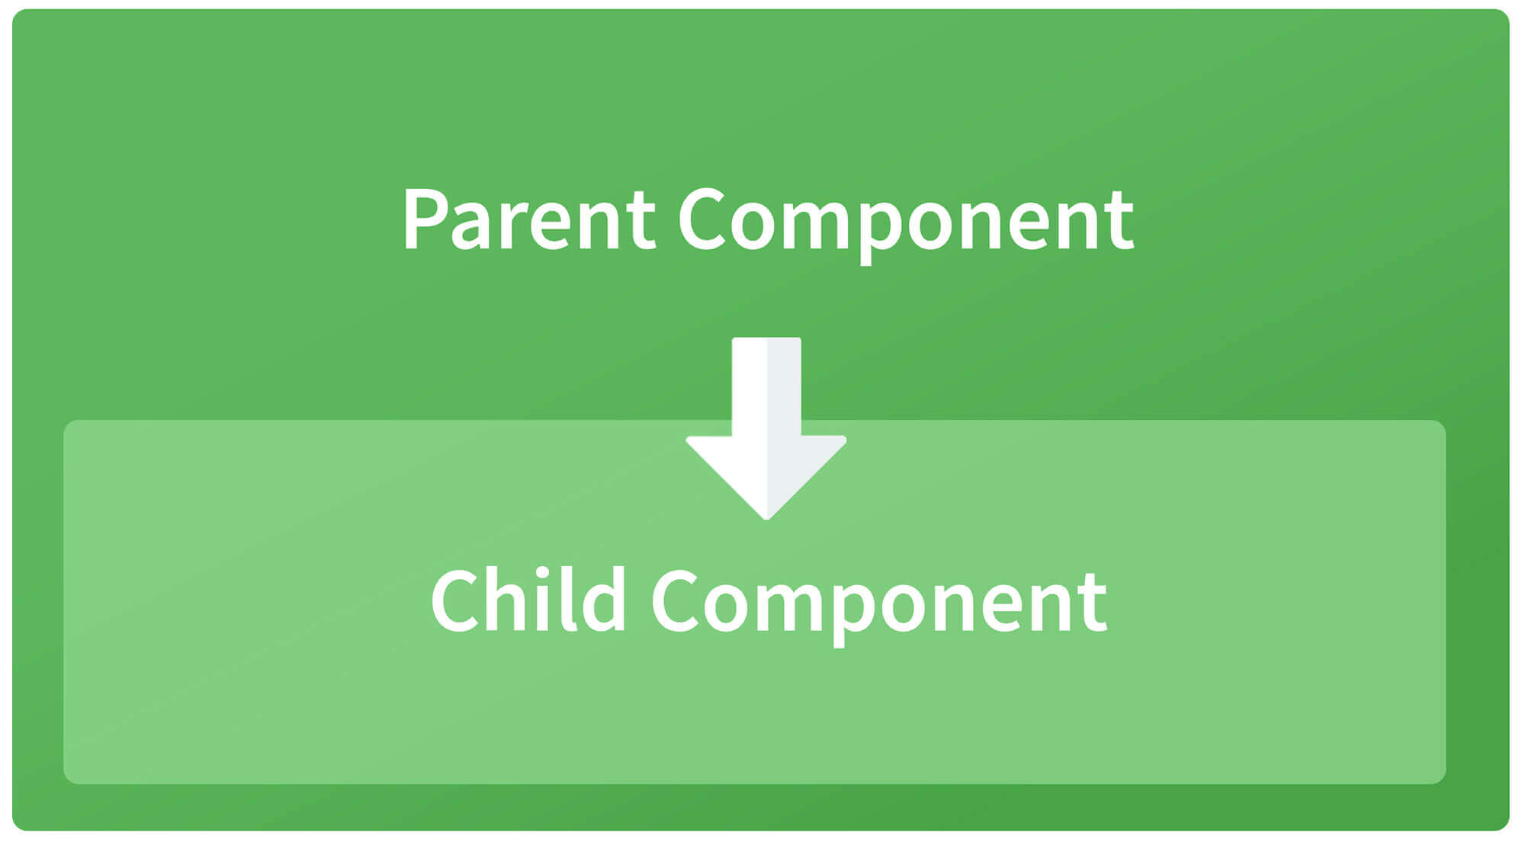
Parent to child using @Input decorator
Consider the following parent component:

@Component({
selector: 'app-parent',
template: `
<app-child [data]=data></app-child>
` ,
styleUrls: ['./parent.component.css']
})
export class ParentComponent{
data:string = "Message from parent";
constructor() { }
}

In the above parent component, we are passing “data” property to the following child component:

import { Component, Input} from '@angular/core';

@Component({
selector: 'app-child',
template:`
<p>{{data}}</p>
`,
styleUrls: ['./child.component.css']
})
export class ChildComponent {
@Input() data:string
constructor() { }
}

In the child component, we are using @Input decorator to capture data coming from a parent component and using it inside the child component’s template.
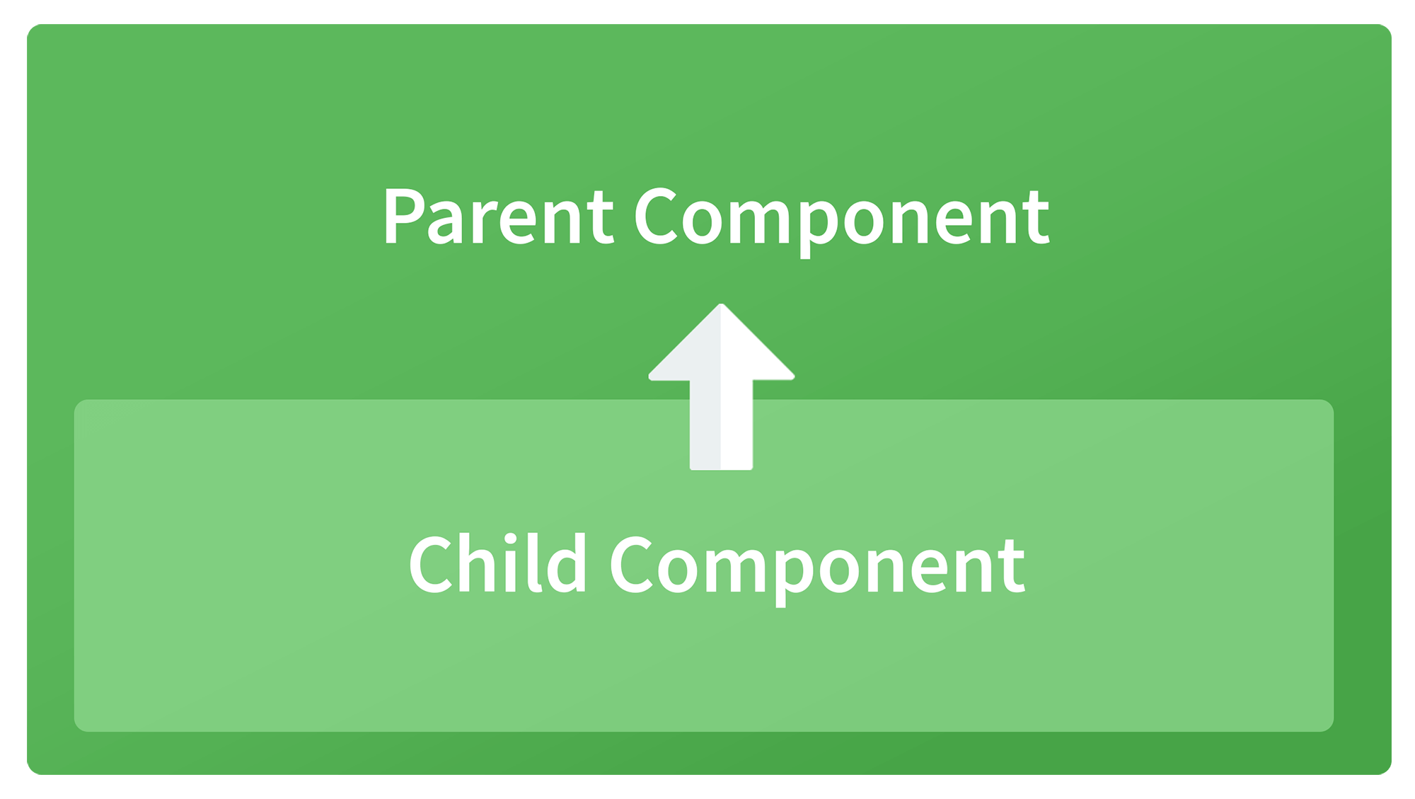
Child to parent using @ViewChild decorator
Child component:

import {Component} from '@angular/core';

@Component({
selector: 'app-child',
template:`
<p>{{data}}</p>
`,
styleUrls: ['./child.component.css']
})
export class ChildComponent {
data:string = "Message from child to parent";
constructor() { }
}

Parent Component

import { Component,ViewChild, AfterViewInit} from '@angular/core';
import { ChildComponent } from './../child/child.component';

@Component({
selector: 'app-parent',
template: `
<p>{{dataFromChild}}</p>
` ,
styleUrls: ['./parent.component.css']
})
export class ParentComponent implements AfterViewInit {
dataFromChild: string;
@ViewChild(ChildComponent,{static:false}) child;

ngAfterViewInit(){
this.dataFromChild = this.child.data;
}
constructor() { }
}

In the above example, a property named “data” is passed from the child component to the parent component.
@ViewChild decorator is used to reference the child component as “child” property.
Using the ngAfterViewInit hook, we assign the child’s data property to the messageFromChild property and use it in the parent component’s template.
Child to parent using @Output and EventEmitter
In this method, we bind a DOM element inside the child component, to an event ( click event for example ) and using this event we emit data that will captured by the parent component:
Child Component:

import {Component, Output, EventEmitter} from '@angular/core';

@Component({
selector: 'app-child',
template:`
<button (click)="emitData()">Click to emit data</button>
`,
styleUrls: ['./child.component.css']
})
export class ChildComponent {

data:string = "Message from child to parent";

@Output() dataEvent = new EventEmitter<string>();

constructor() { }

emitData(){
this.dataEvent.emit(this.data);
}
}

As you can see in the child component, we have used @Output property to bind an EventEmitter. This event emitter emits data when the button in the template is clicked.
In the parent component’s template we can capture the emitted data like this:

<app-child (dataEvent)="receiveData($event)"></app-child>

Then inside the receiveData function we can handle the emitted data:

receiveData($event){
this.dataFromChild = $event;
}

14. Explain the concept of Dependency Injection?
Dependency injection is an application design pattern which is implemented by Angular.
It also forms one of the core concepts of Angular.
So what is dependency injection in simple terms?
Let’s break it down, dependencies in angular are nothing but services which have a functionality. Functionality of a service, can be needed by various components and directives in an application. Angular provides a smooth mechanism by which we can inject these dependencies in our components and directives.
So basically, we are just making dependencies which are injectable across all components of an application.
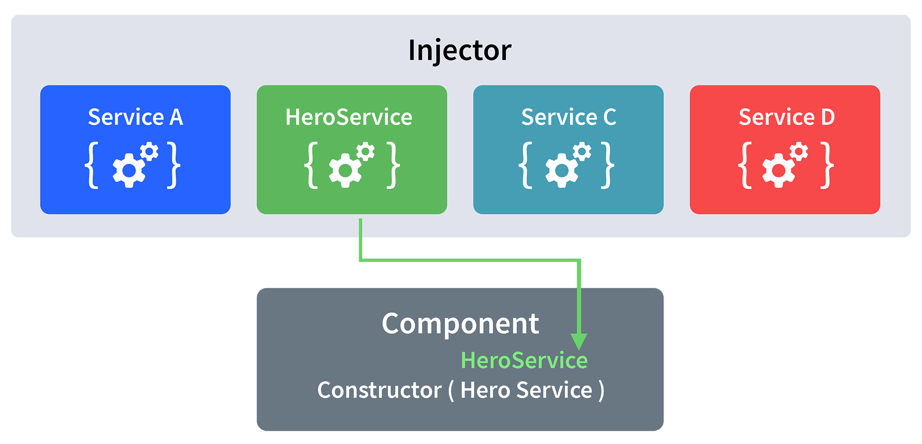
Let’s understand how DI (Dependency Injection) works:
Consider the following service, which can be generated using:
ng g service test

import { Injectable } from '@angular/core';

@Injectable({
providedIn: 'root'
})
export class TestService {
importantValue:number = 42;

constructor() { }

returnImportantValue(){
return this.importantValue;
}
}

As one can notice, we can create injectable dependencies by adding the @Injectable decorator to a class.
We inject the above dependency inside the following component:

import { TestService } from './../test.service';
import { Component, OnInit } from '@angular/core';

@Component({
selector: 'app-test',
templateUrl: './test.component.html',
styleUrls: ['./test.component.css']
})
export class TestComponent implements OnInit {
value:number;
constructor(private testService:TestService) { }

ngOnInit() {
this.value = this.testService.returnImportantValue();
}
}

One can see we have imported our TestService at the top of the page. Then, we have created an instance inside the constructor of the component and implemented the returnImportantValue function of the service.
From the above example, we can observe how angular provides a smooth way to inject dependencies in any component.
15. Explain MVVM architecture
MVVM architecture consists of three parts:
1. Model
2. View
3. ViewModel
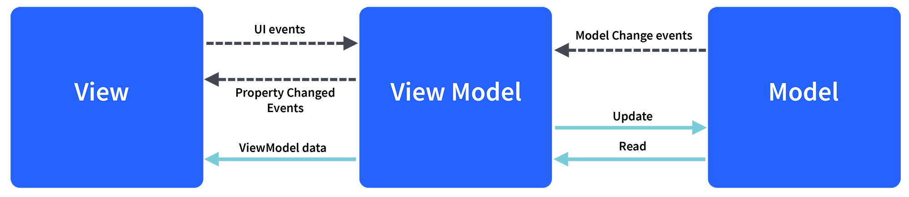
Model contains the structure of an entity. In simple terms it contains data of an object.
View is the visual layer of the application. It displays the data contained inside the Model. In angular terms, this will be the HTML template of a component
What is one way binding and two way binding in angular
https://www.pluralsight.com/guides/one-and-two-way-data-binding-angular
What is property binding and event binding in Angular
https://coursetro.com/posts/code/108/Angular-5-Interpolation,-Property-Binding-&-Event-Binding-Tutorial
https://angular.io/guide/property-binding
https://angular.io/guide/event-binding
What is use of @Input() @Output() angular
https://angular.io/guide/inputs-outputs
what is routing guard in angular
https://codeburst.io/understanding-angular-guards-347b452e1892
what is ngShow , and ng Hide
https://www.geeksforgeeks.org/define-ng-if-ng-show-and-ng-hide/
https://www.guru99.com/angularjs-events.html
How to define routing in angular
what is equivalant to ngshow and nghide
what is difference between component and directive
what is observable .
how would you protect a component being activated through the roughter
How do you categorize data binding types
What is the porpose of wildcard routes
when would you use eager module loading
How do you perform error handling in Observables
Why shoud ngObInit be used if we already have a constructor ?
What is multicasting
How do you perform Error Handling for HttpClient
What is difference between declarations , providers and import in ngModule
What is reactive programming and how does it relate to Angular
Are there any prose/cons(performance wise) in using local storate to replae cookie functionality
What is lvy Renderer ?
what are the life cycle hooks for the componentes and directives .
What is Angular universal .

